Create “Pre-Departure 2015” on System Event

Create Pre-Departure event first.

- Click Event choose Event
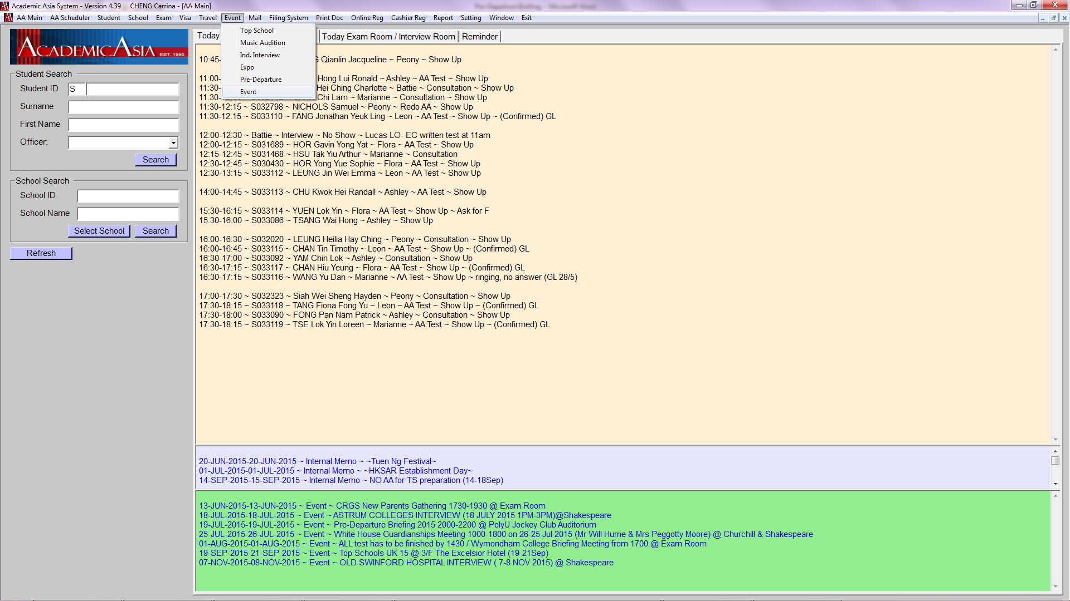

On the Event page click New
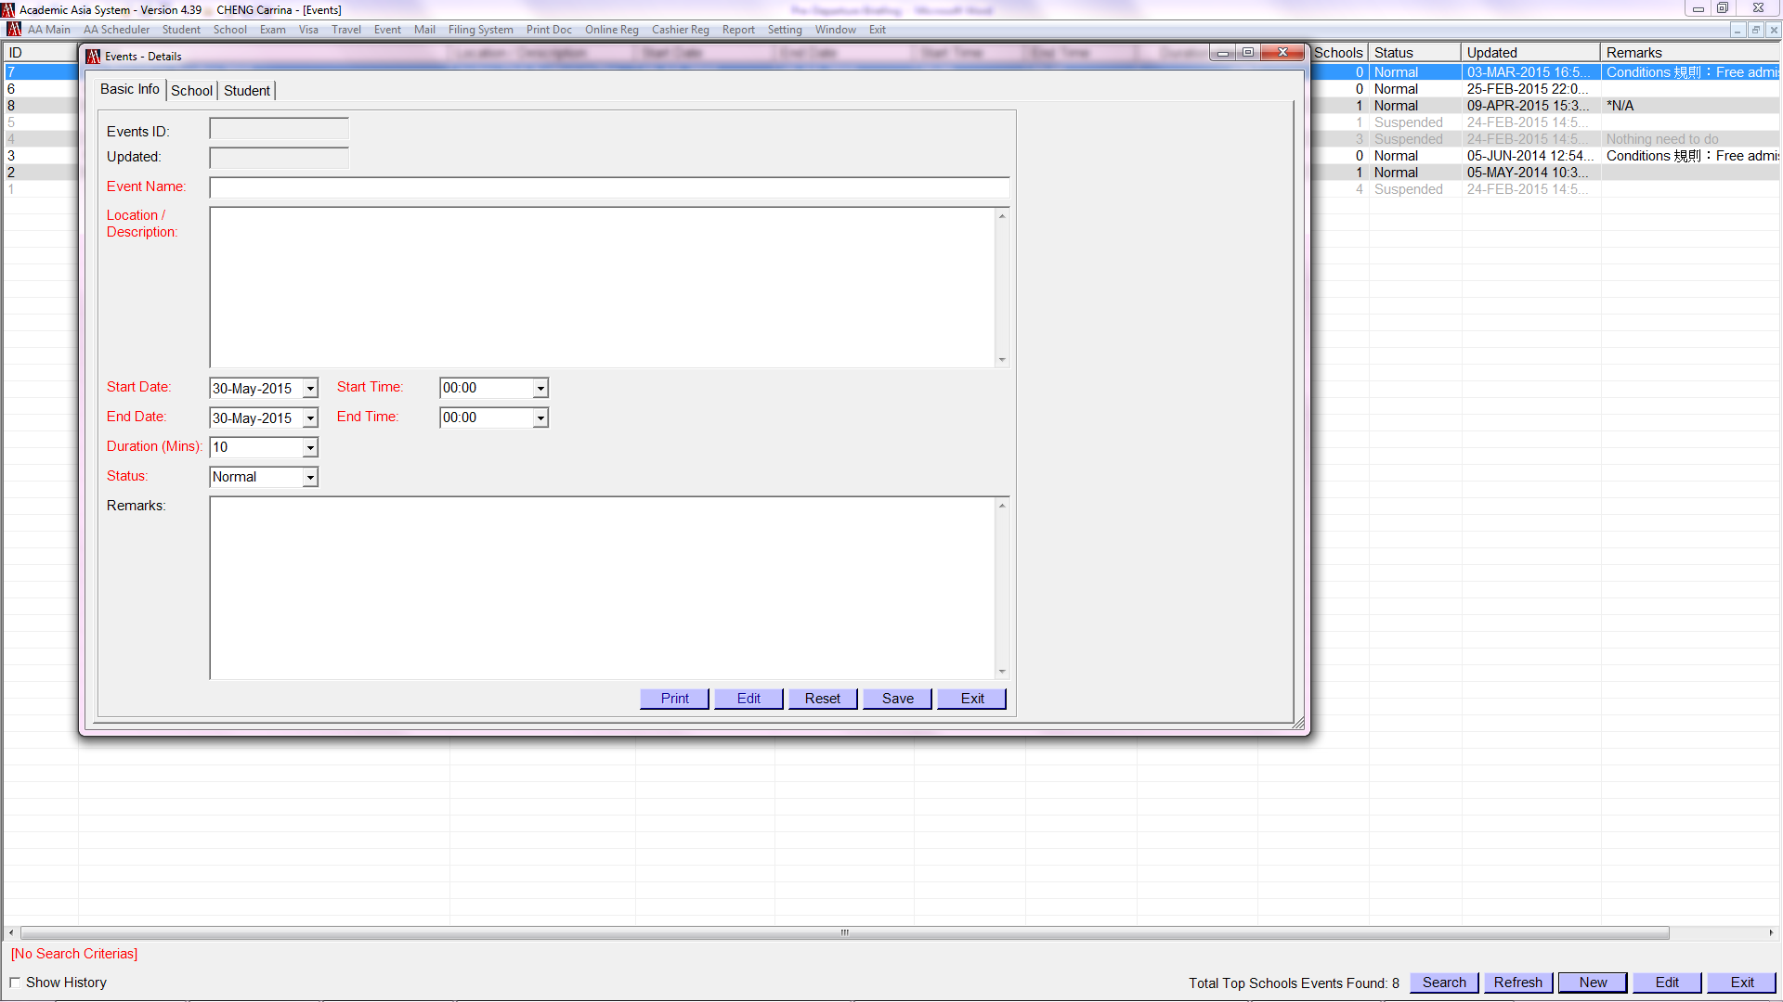

Create “Pre-Departure 2015” on System Event (con’t)

- Fill in necessary information in the pop-up box click Save
- The pop-up window will close automatically, and the event will appear on the Event page
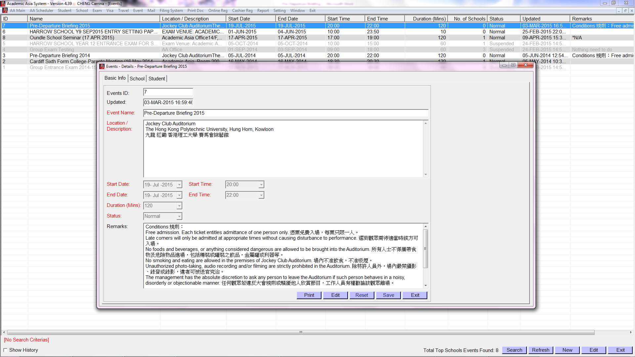

Create “Pre-Departure 2015” on System Event

Then create White House interview event.

- Click Event choose Ind. Interview
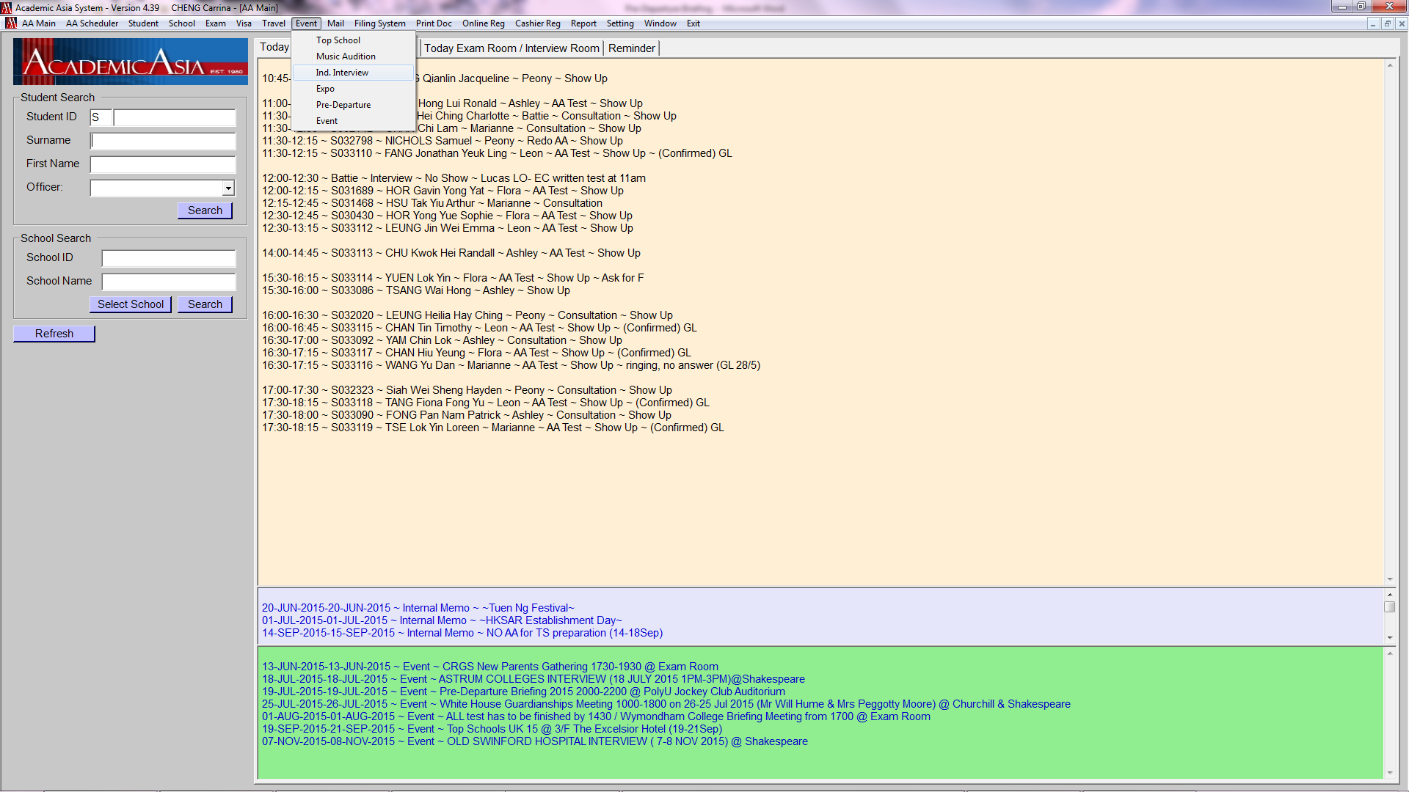

Click New enter necessary details click Save
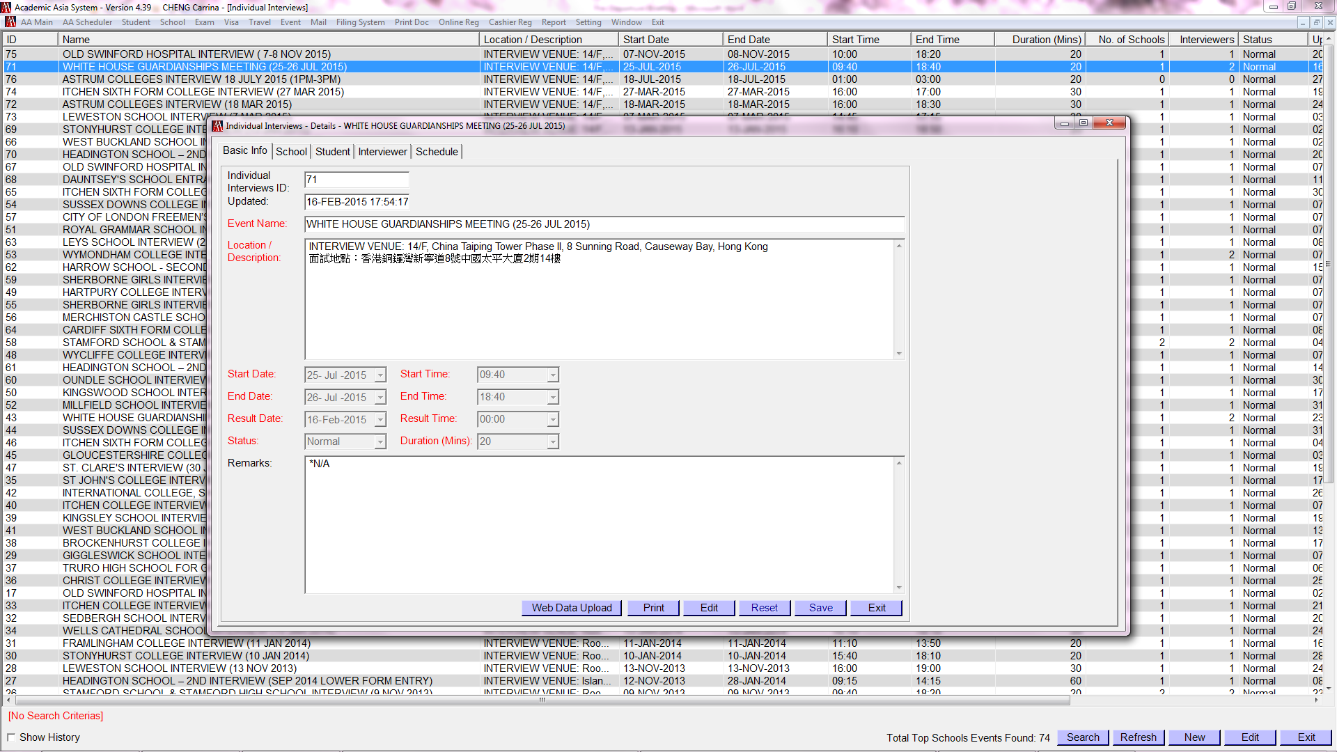

Basic Operation

- Click Event Pre-Departure
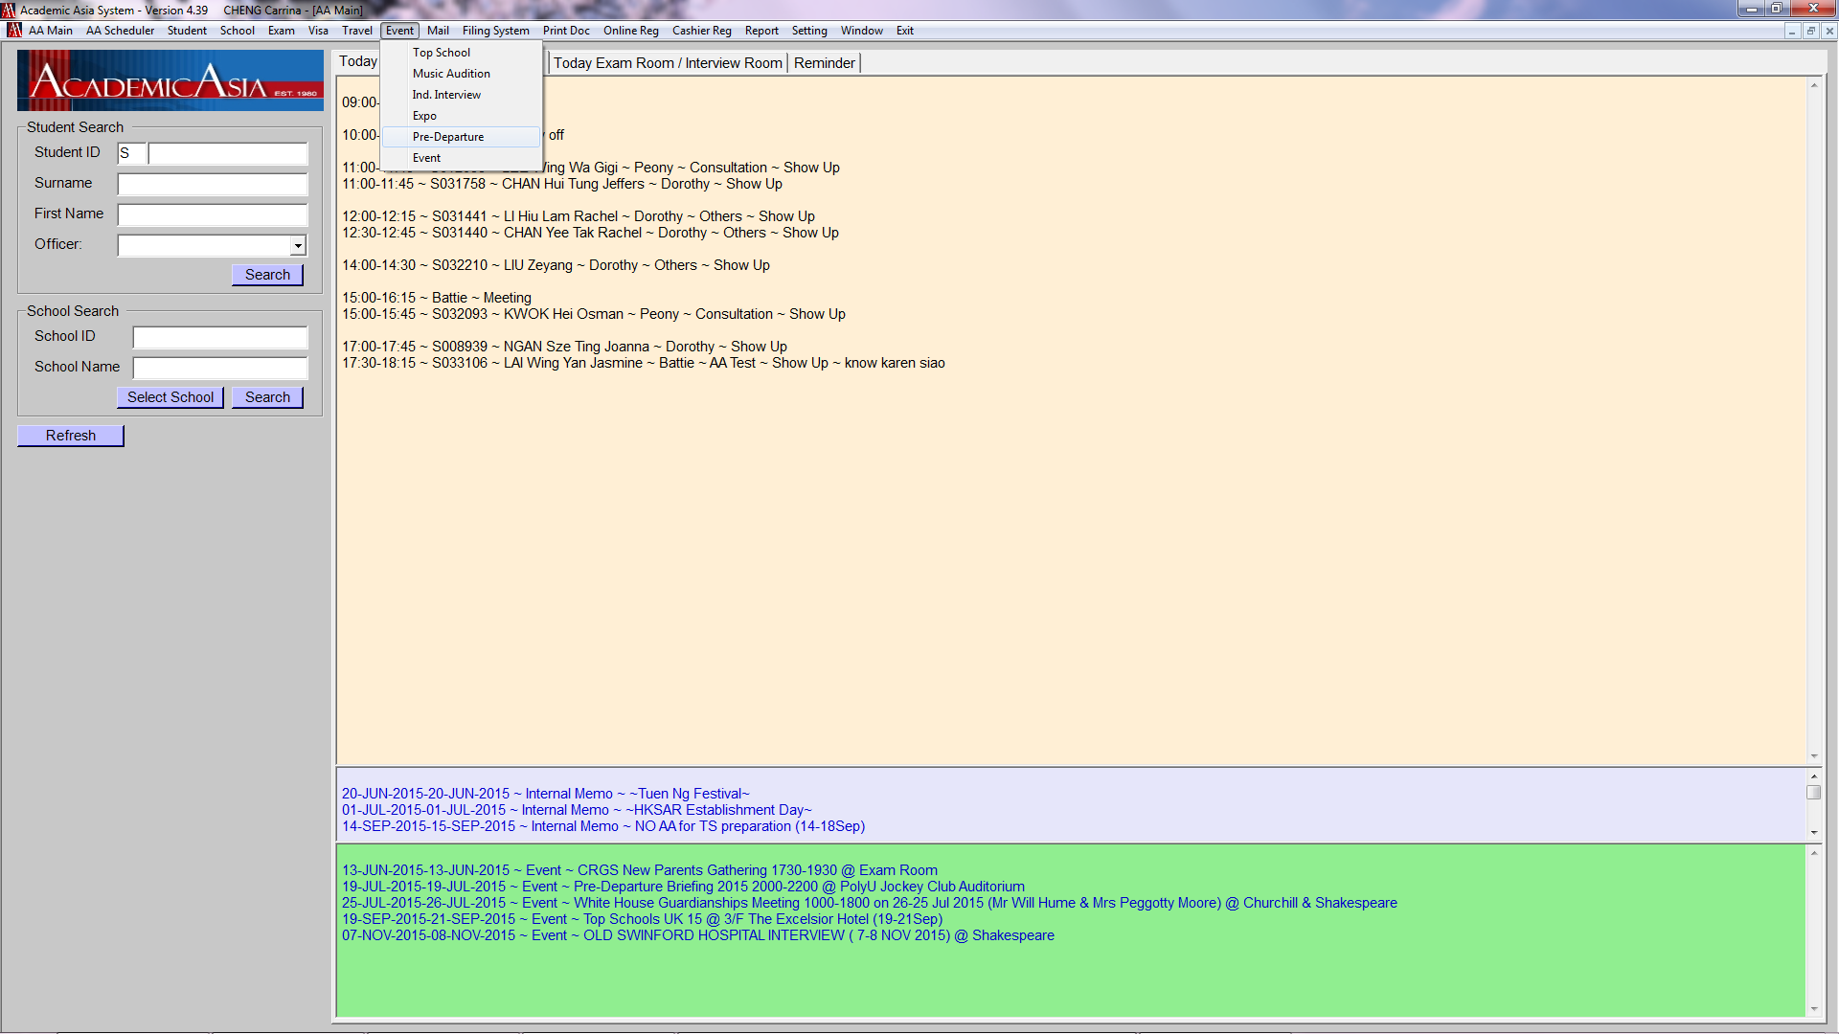

- By default, it shows all new deposited students of the coming academic year in surname’s alphabetical order
- Double Deposit : Do not add the one with unwanted School Application to Event and Interview
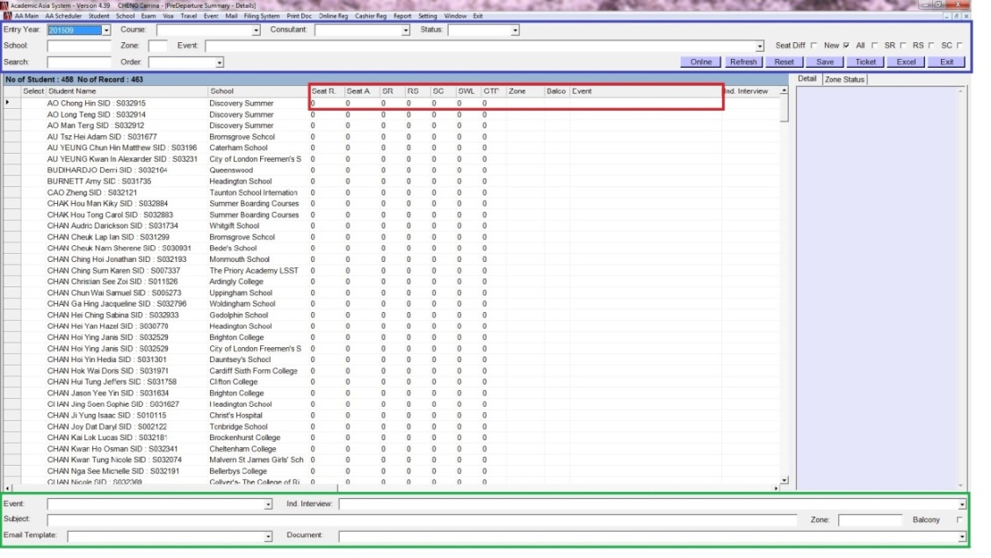

Explanation of some fields in the above boxes:
Search | may search SID / school name / student’s name (either surname or first name, can’t be full name)
Order | allow selecting the display order
Seat Diff | show the difference of the Seat Requested (Seat R) Seat Assigned (Seat A)
New | New Deposit and haven NOT done anything yet
All | All Deposit in Sep2015, including emailed and non-emailed students
SR | Sent Request
RS | Reply Slip Received
SC | Sent Confirmation
Seat R | number of Seat Requested
Seat A | number of Seat Assigned
SWL | Sent confirmation email on Waiting List
GTP | Got Ticket Pack (the Admission Pack)
Subject | Subject of the email
Email Template | Select Invitation/Confirmation etc email templates
Document | attachment

Testing the Online Registration Link
- Test to make sure the registration link, login name and password are work before sending email to the families
- Try to fill in the information and insert the number of tickets to see whether the information can be shown on AA System
- Liaise with PSC if there is question re the registration link

- Enter URL http://academic-asia.com/pre-departure/login.php in browser
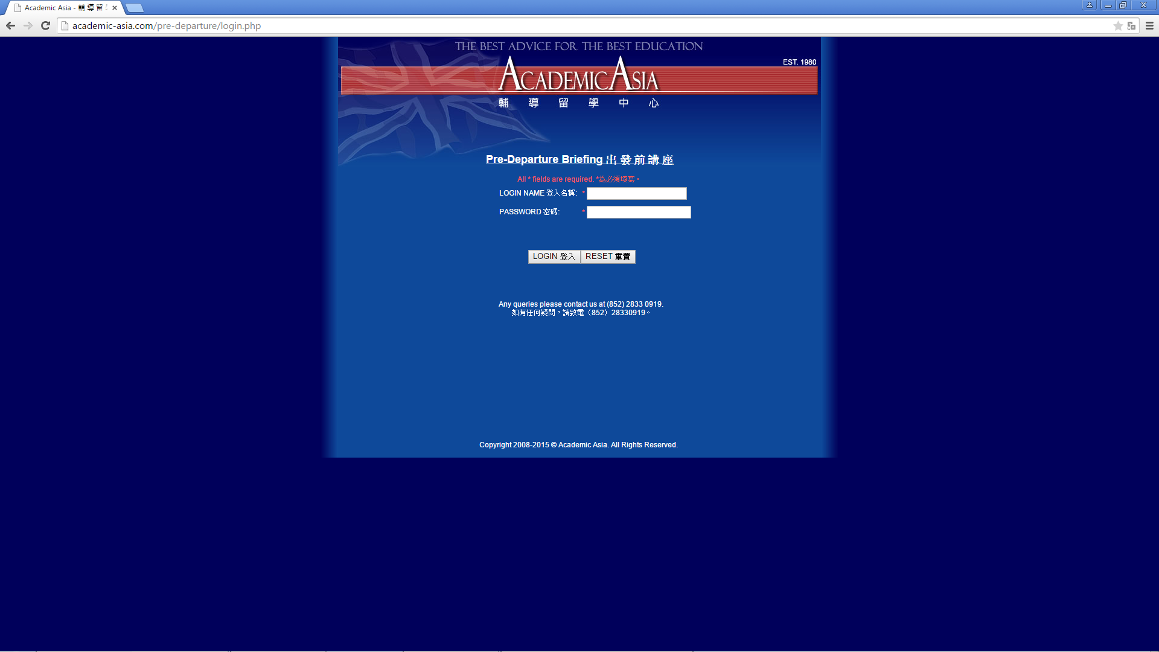

Update students to Event and interview on AA System:

- Tick “All” on top right-hand corner at the first time in order to select ALL Sep2015 (Entry Year 201509) deposited students
- Right click a box on the left-hand side choose Select All
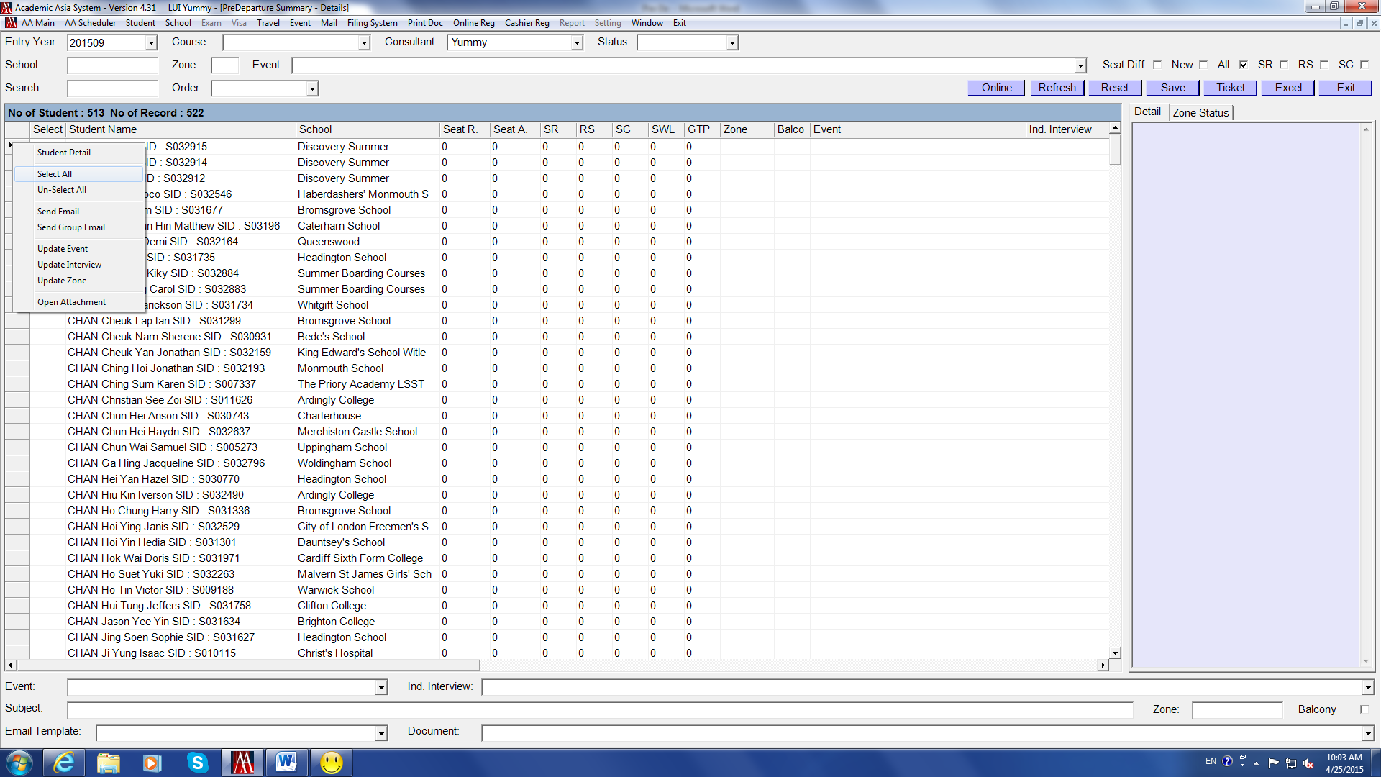

- “1” will appear beside all the student names
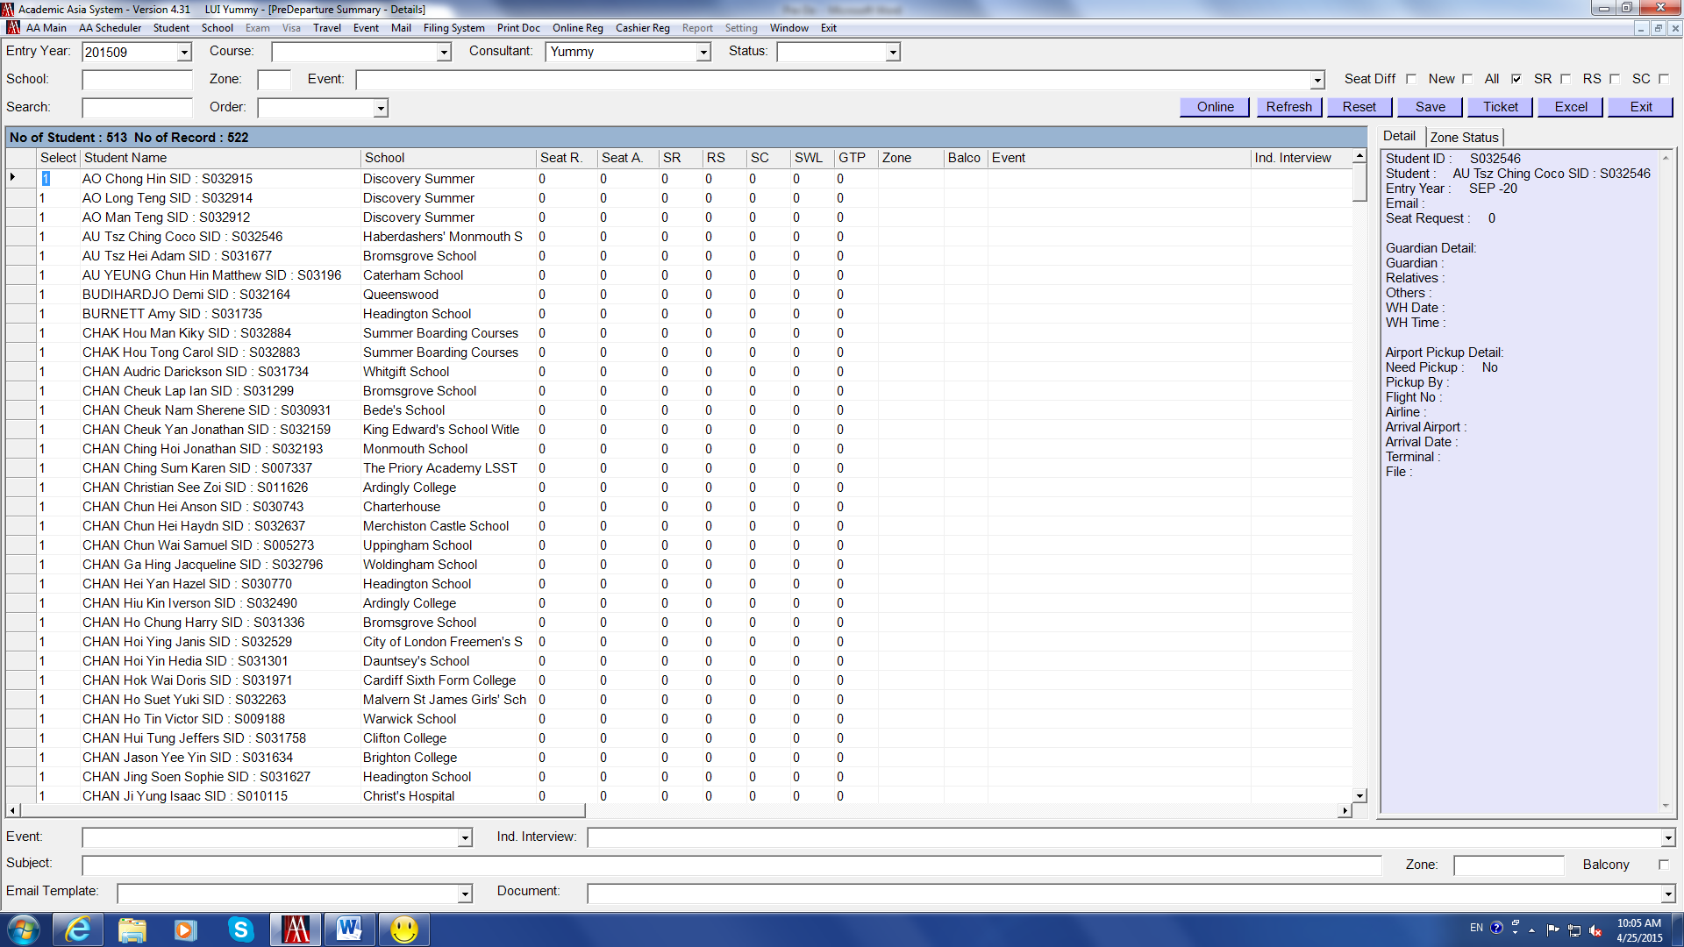

We usually DON’T send invitation email to students who are:
- Drop
- Summer course
- Referral
- Living overseas
Need to unselect those students with above status.
For students with more than one deposited record, check with consultant in charge (CIC) which school area the student should be allocated for Pre-De briefing
Update students to Event and interview on AA System: (con’t)

- Double-click the box on the left-hand side to unselect the “Drop” students “1”will then disappear
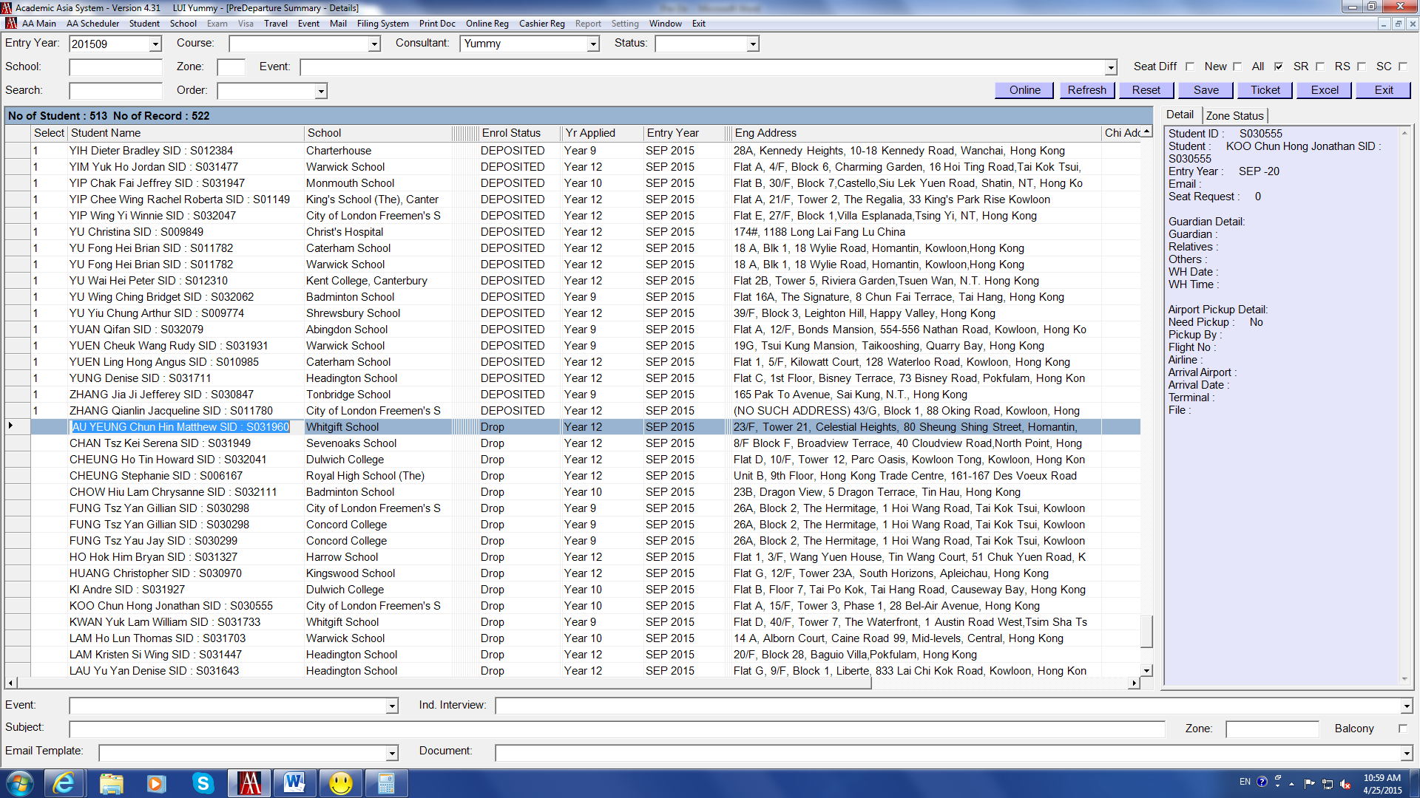

- Also unselect students who are “Summer Course”, “Referral”, “Living Overseas”
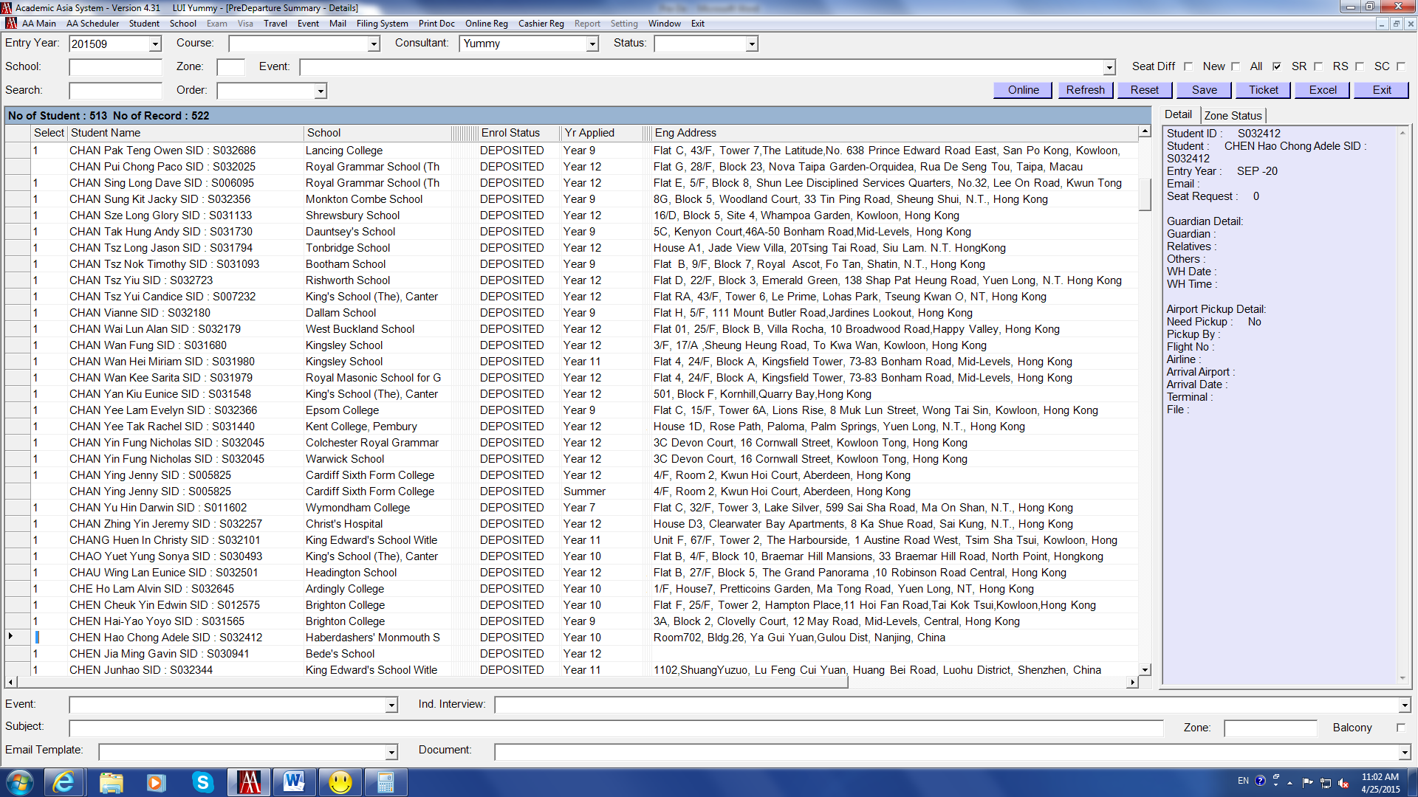

Update students to Event and interview on AA System: (con’t)

When correct students have been shortlisted
- Select Event “Pre Departure Briefing 2015”, Ind Interview “White House…”
- Click a box on the left-hand side right click choose Update Event, then Update Interview
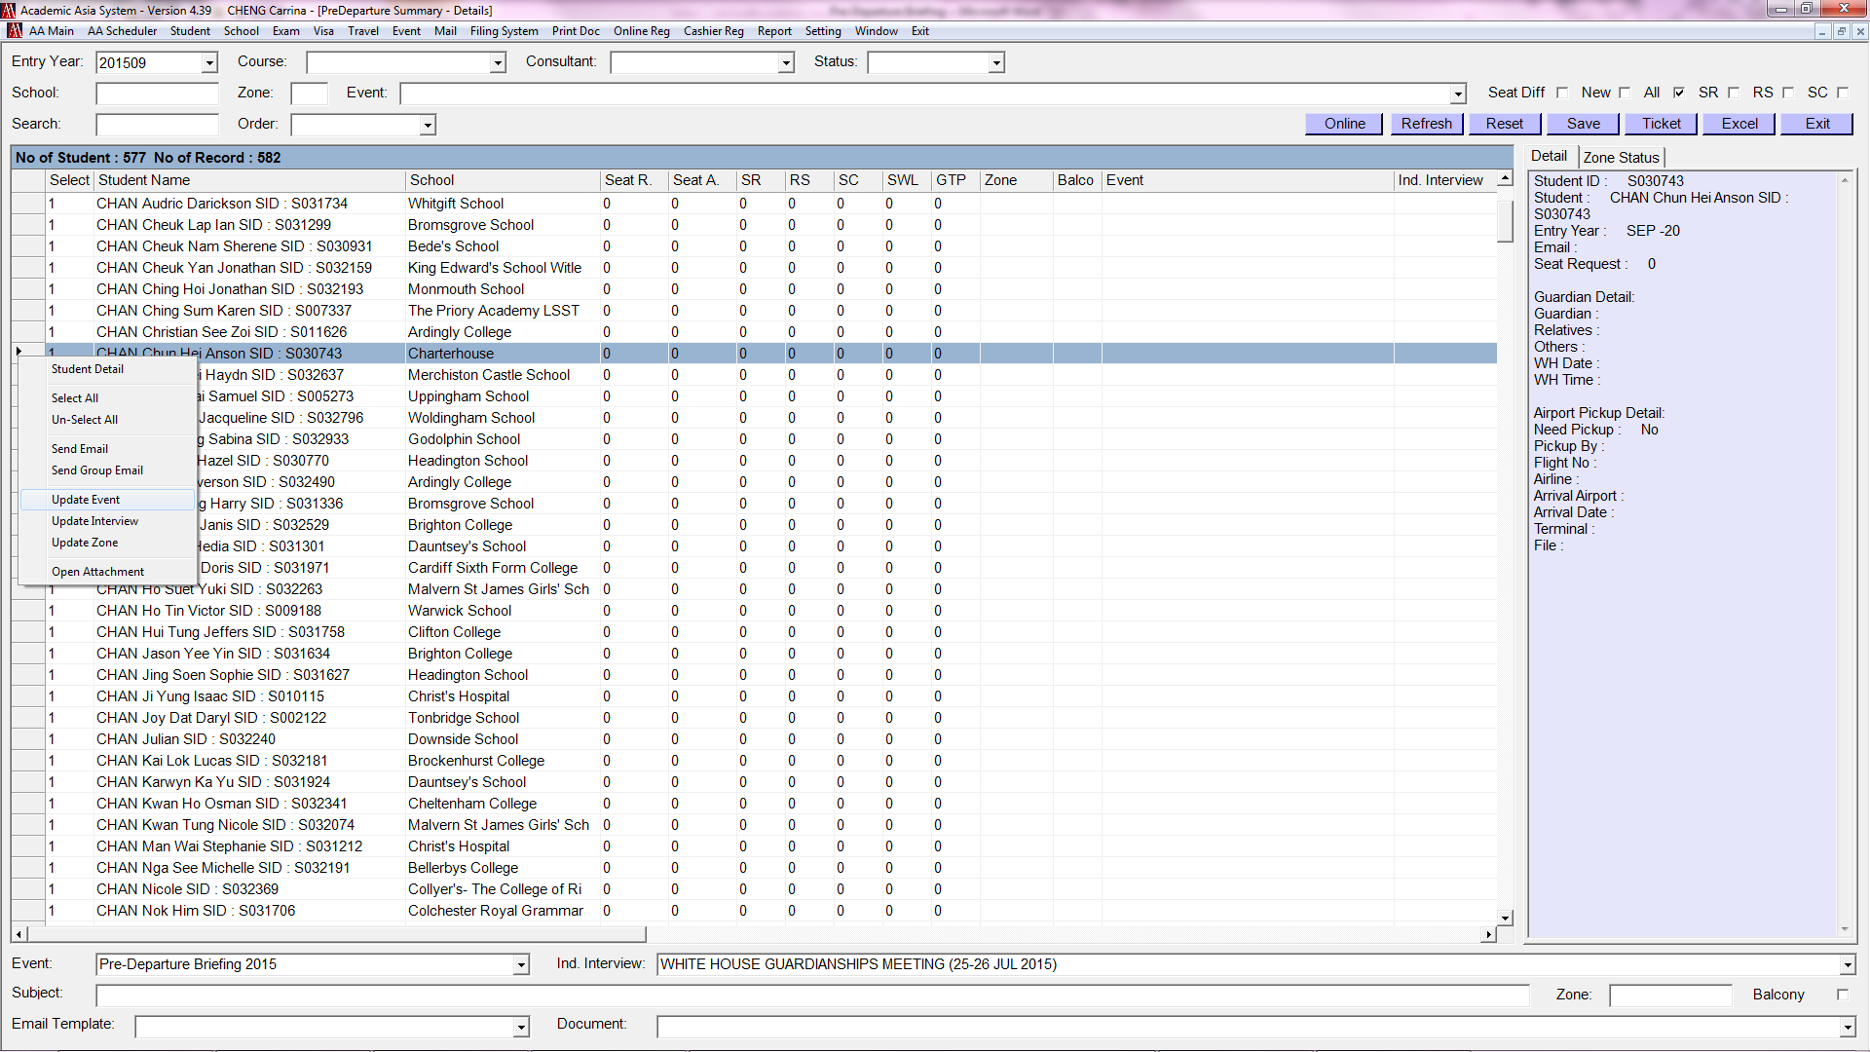

- Once clicked Update Event and Update Interview, this will be shown on row
- Click Save
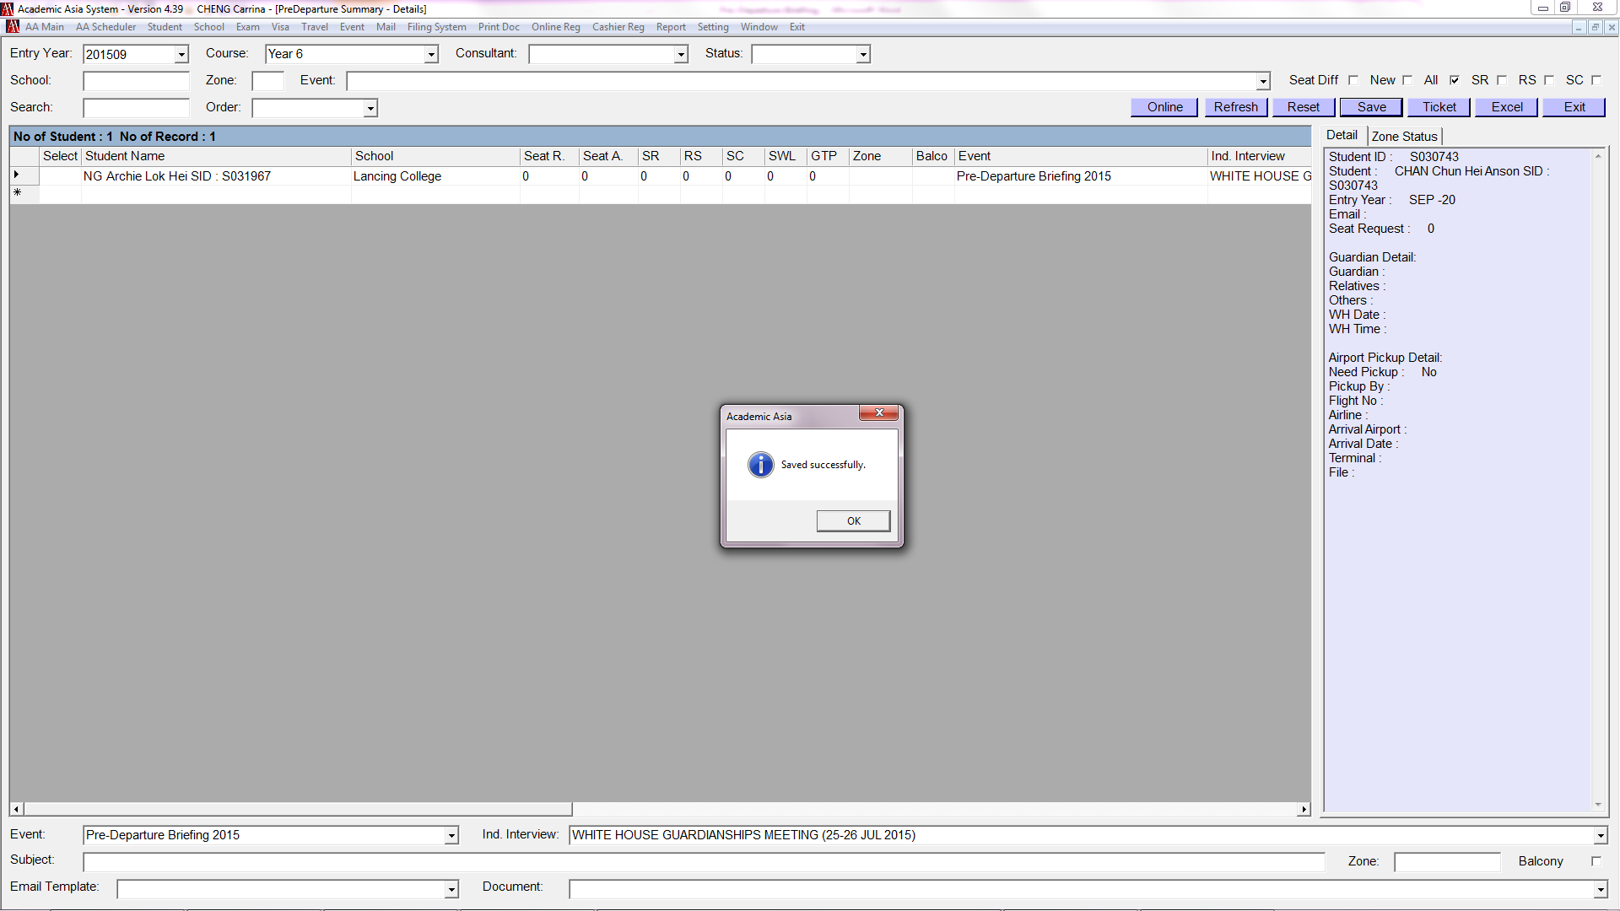

Send Invitation Email – AFTER Updating the Event: (con’t)

- Event has been added for the above selected students
- Unclick all the boxes at the top right-hand corner, you can find the list of students that you have already updated the event column
(This is because you have already clicked Save, they are no longer new records)
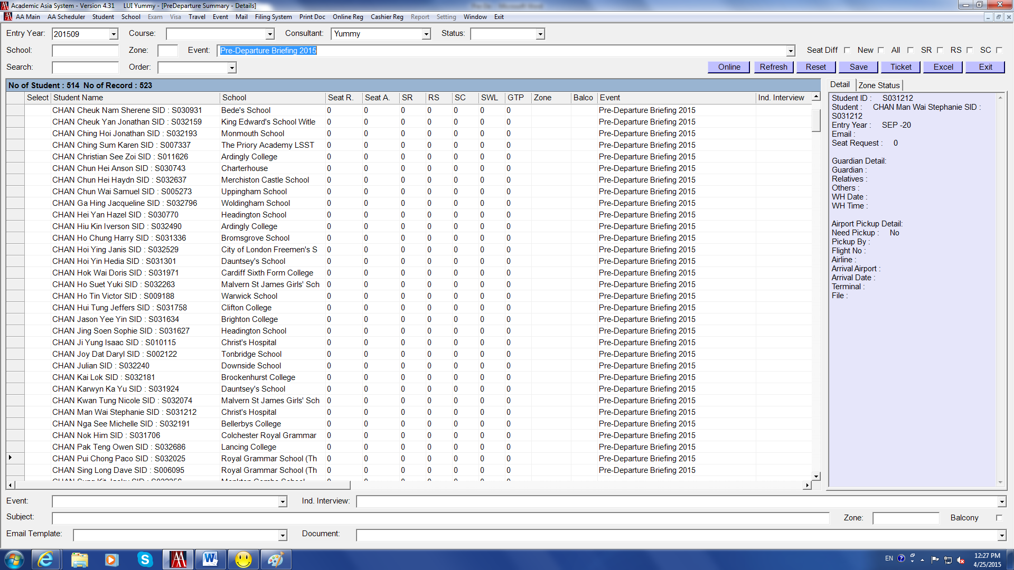

Send Invitation Email – AFTER Updating the Event (con’t)

- Unclick all the boxes at the top right-hand corner
- Select Event “Pre-Departure Briefing 2015”
- Select Course “Year X” (sending by year group for easy management), the selected year group students will be shown on the page
IMPORTANT: We only send ONE email to each student because NEW Login ID and Password will be generated automatically whenever we generate a new email to a student
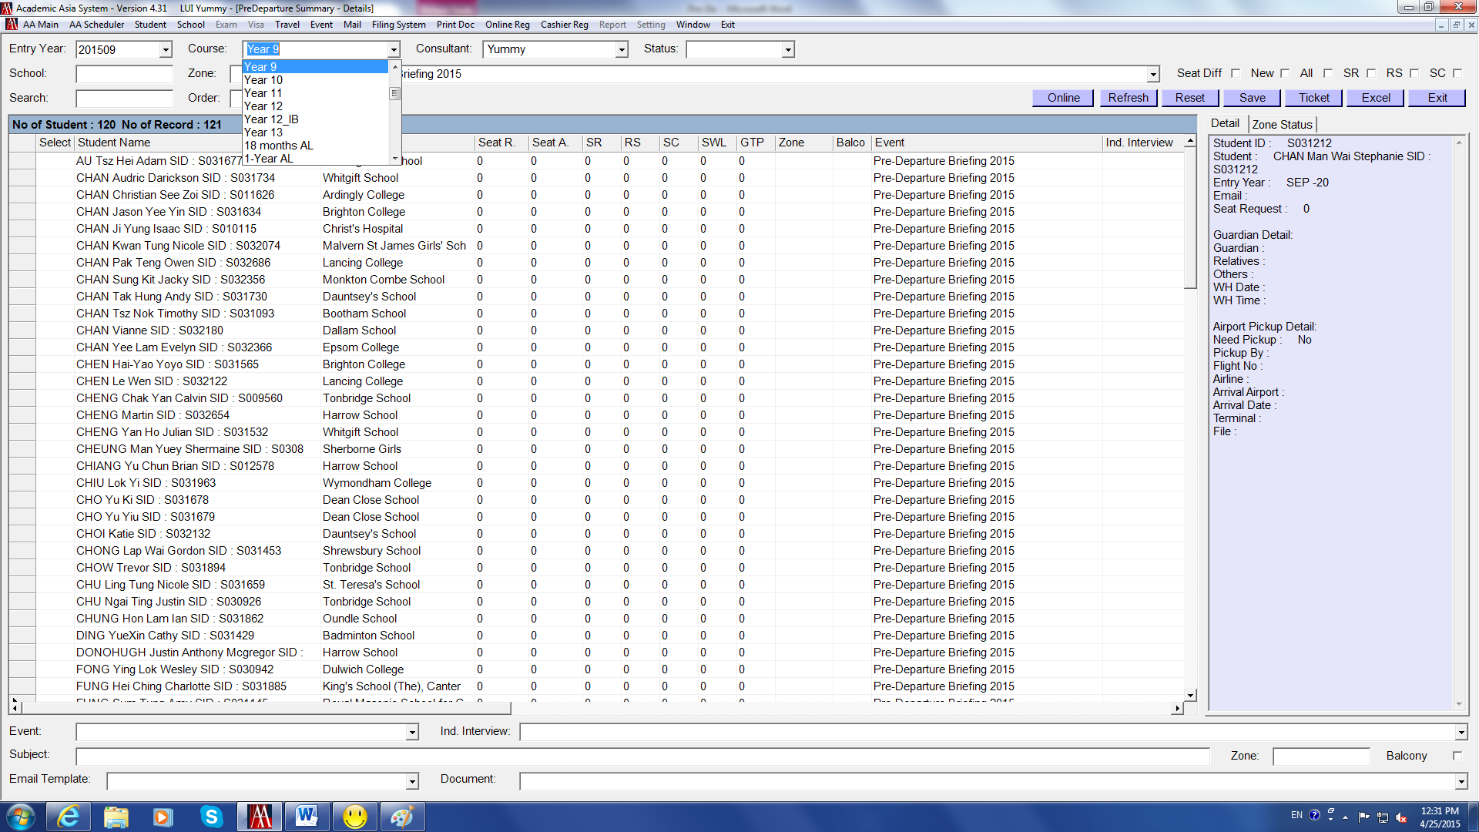

- Right click a box on the left-hand side choose Select All, “1” will then appear beside the students’ name
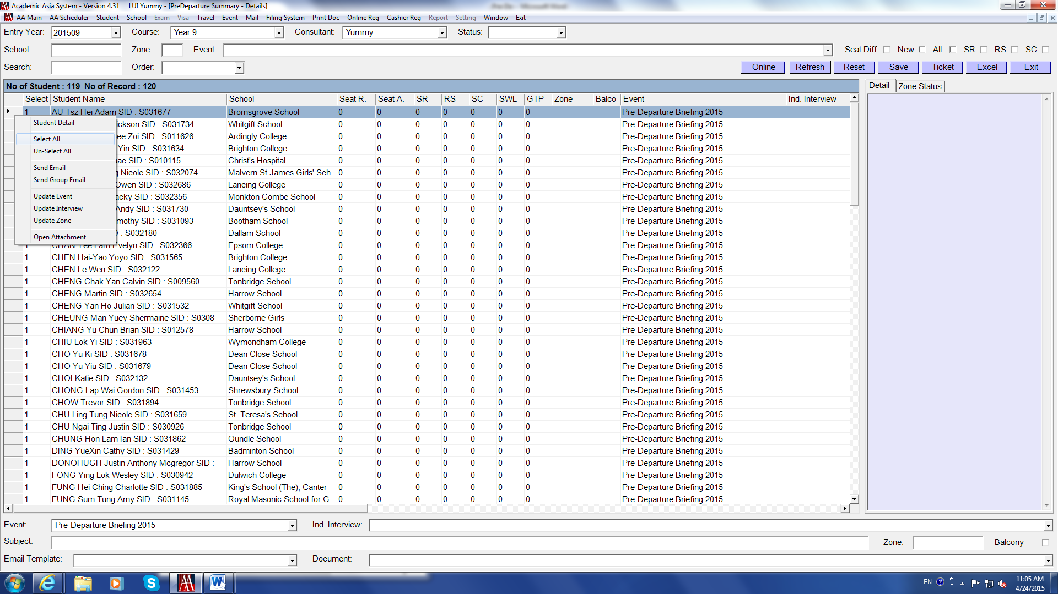

Send Invitation Email – AFTER Updating the Event (con’t)

- To avoid sending duplicated emails to one student, arrange the display Order by “Student Name”, the list will then be shown in the order of students’ surname
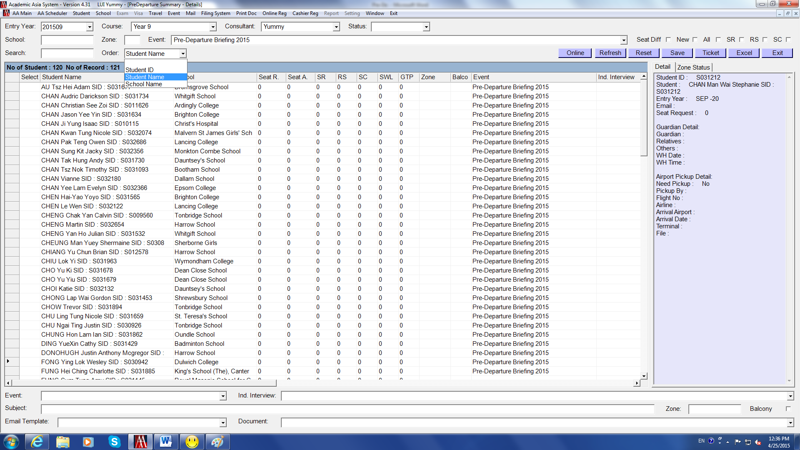

*Now double check if Drop, Summer Course, Referral, Living Overseas have been removed*

- Select Event “Pre-Departure 2015” and Email Template [Invitation], Set up Pre-Departure Email template beforehand, use previous email template as reference.
Enter Subject “Pre-Departure 2015_Invitation Email”
Select Document (if any)
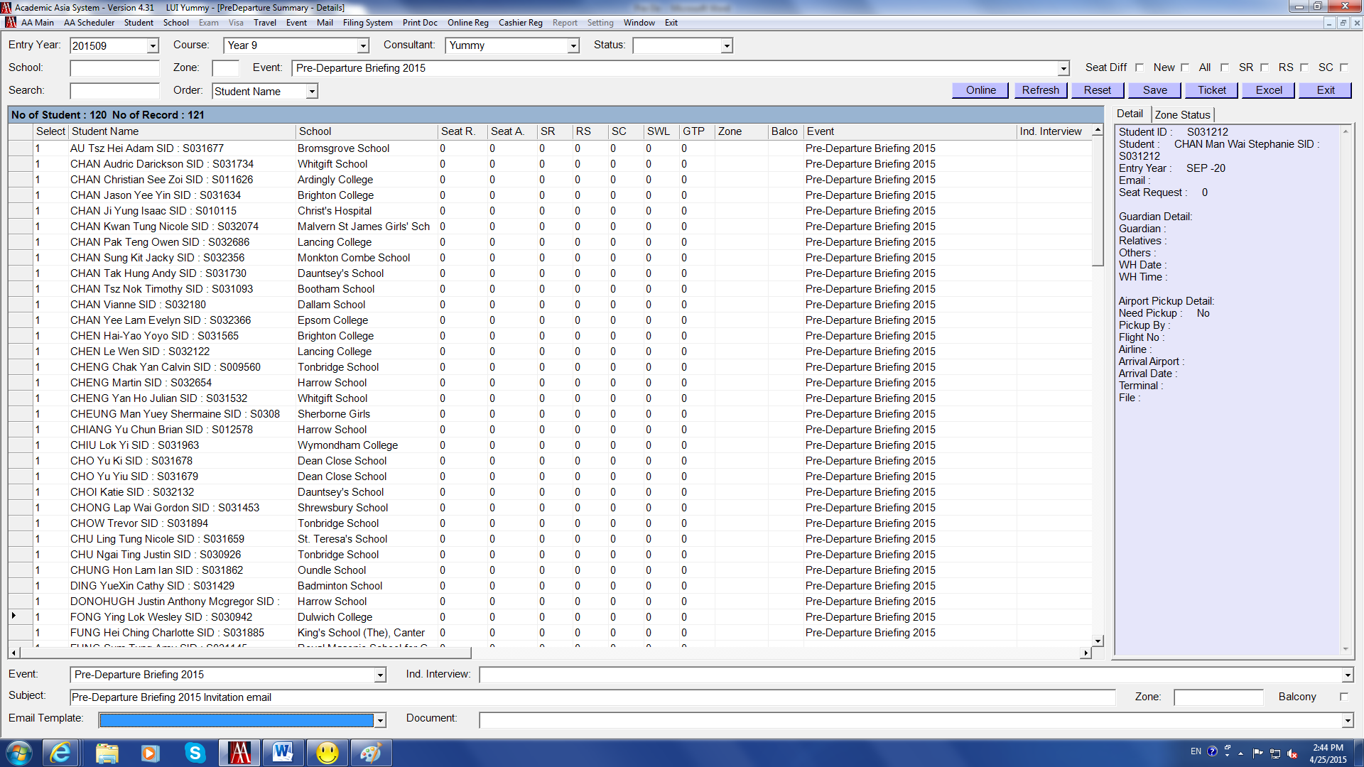

Send Invitation Email – AFTER Updating the Event (con’t)

- Right click a box on the left-hand side choose Send Group Email. If use “Send Email”, the sender of the email will appeared : Battie@academic-asia.com. So Please do not use “Send Email”.
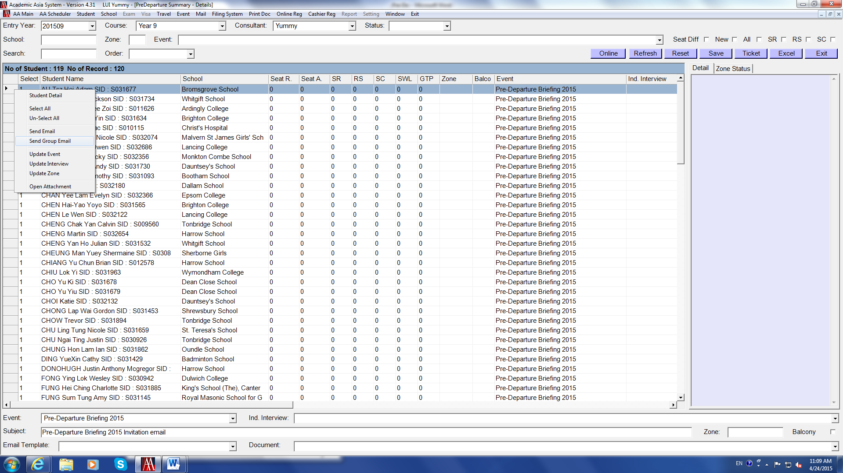

- A pop-up window saying “Bulk mail pool updated successfully” comes up click OK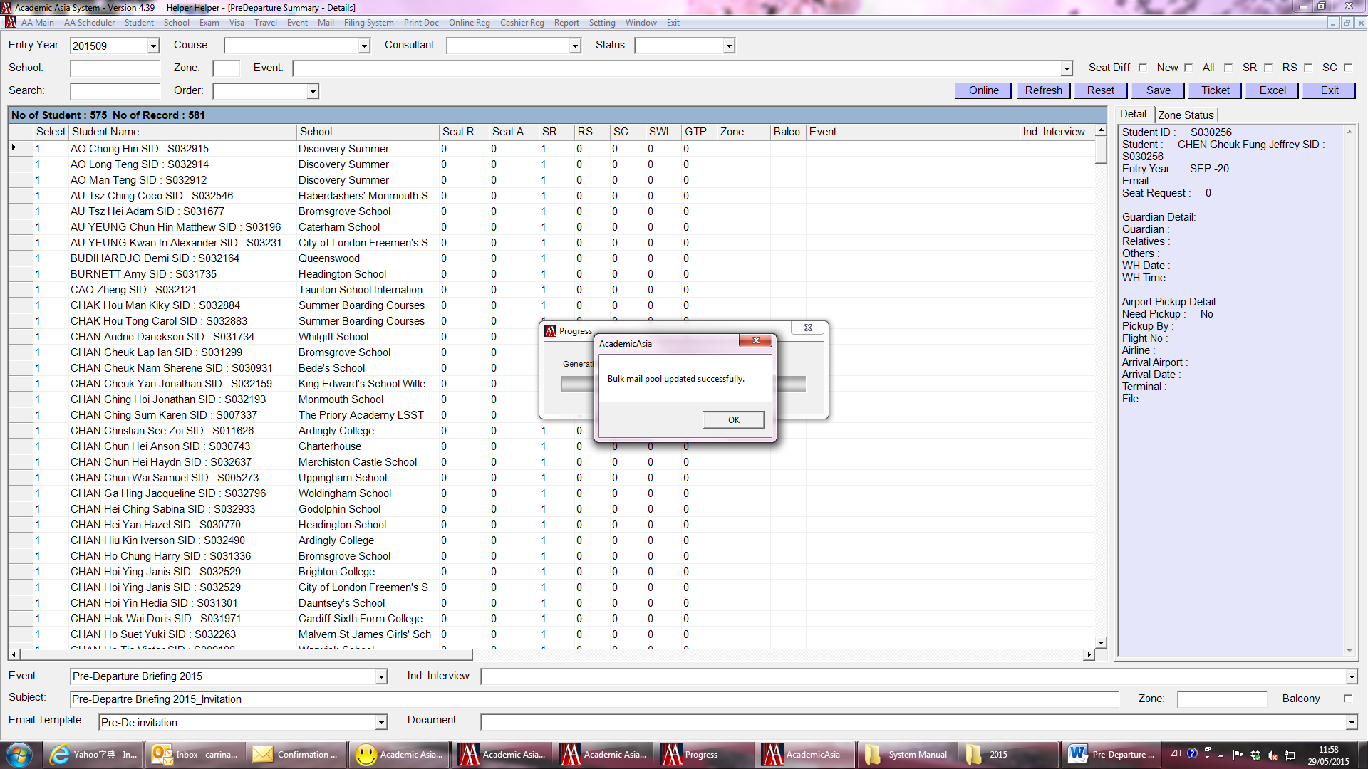

Send Invitation Email – AFTER Updating the Event (con’t)

- Go to Mail Bulk Mail
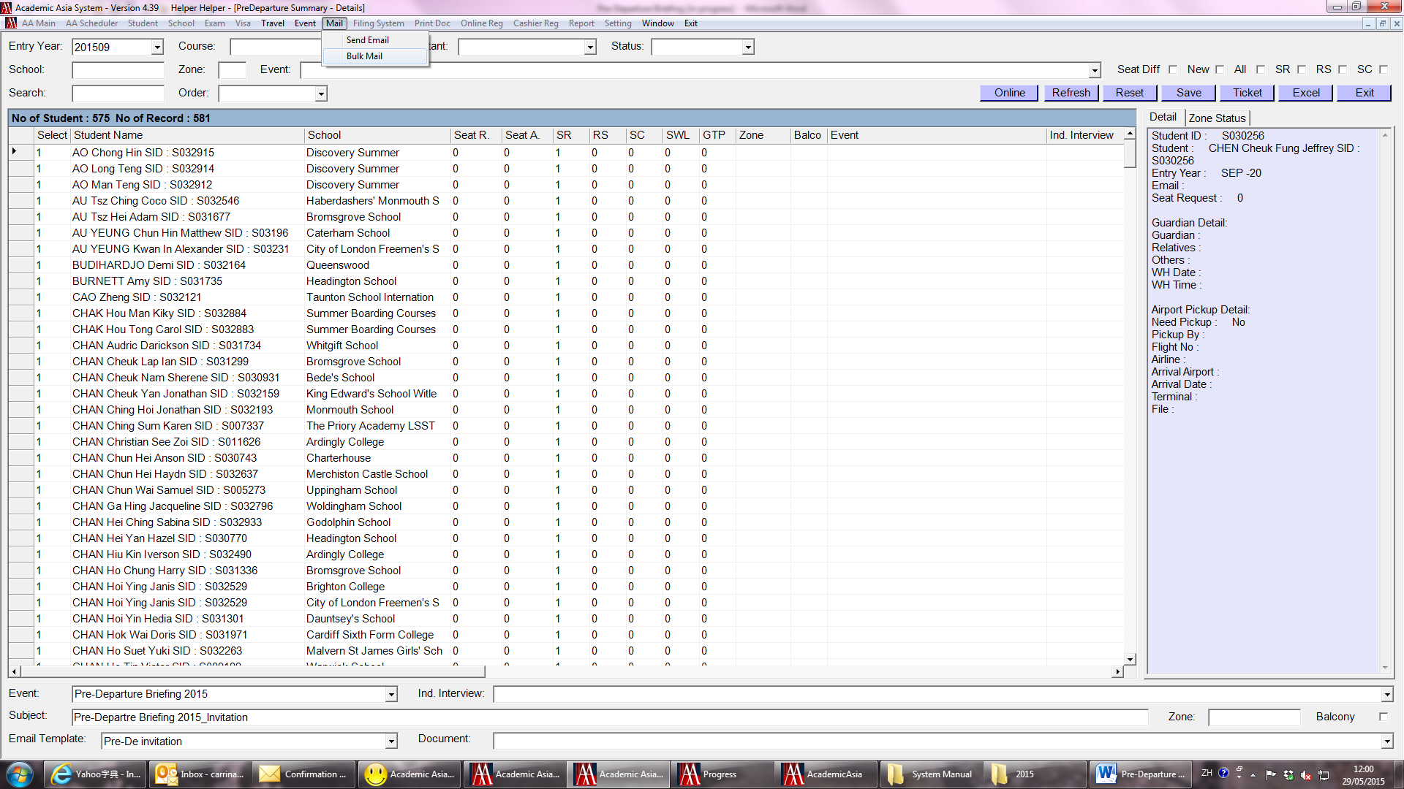

- Click Details section select Subject at the top, enter Interval at the bottom (around 2-3 seconds if no attachment)
- Check the email content is correct again click Send (similar to usual Bulk Mail sending)
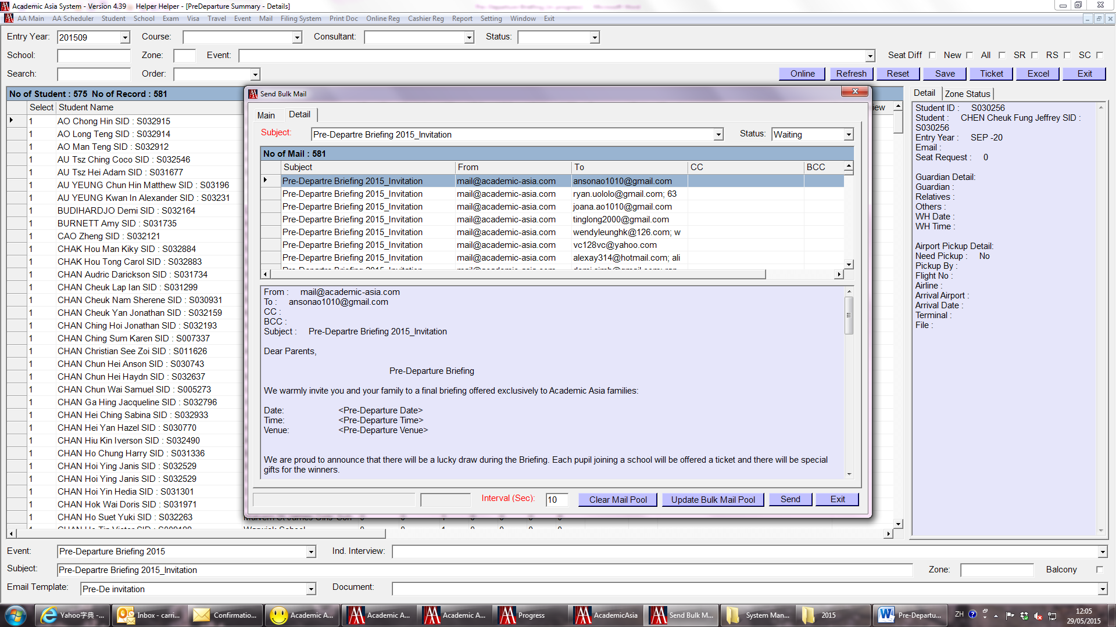

Send Invitation Email – AFTER Updating the Event (con’t)

- Go back to Pre-Departure page, click Save once you start sending the badge of invitation email
“1” will be display in the SR column, which means this has been done (this is important step, if you don’t save, the SR column will go back to “0” indicating you have not sent the invitation email to the families.)
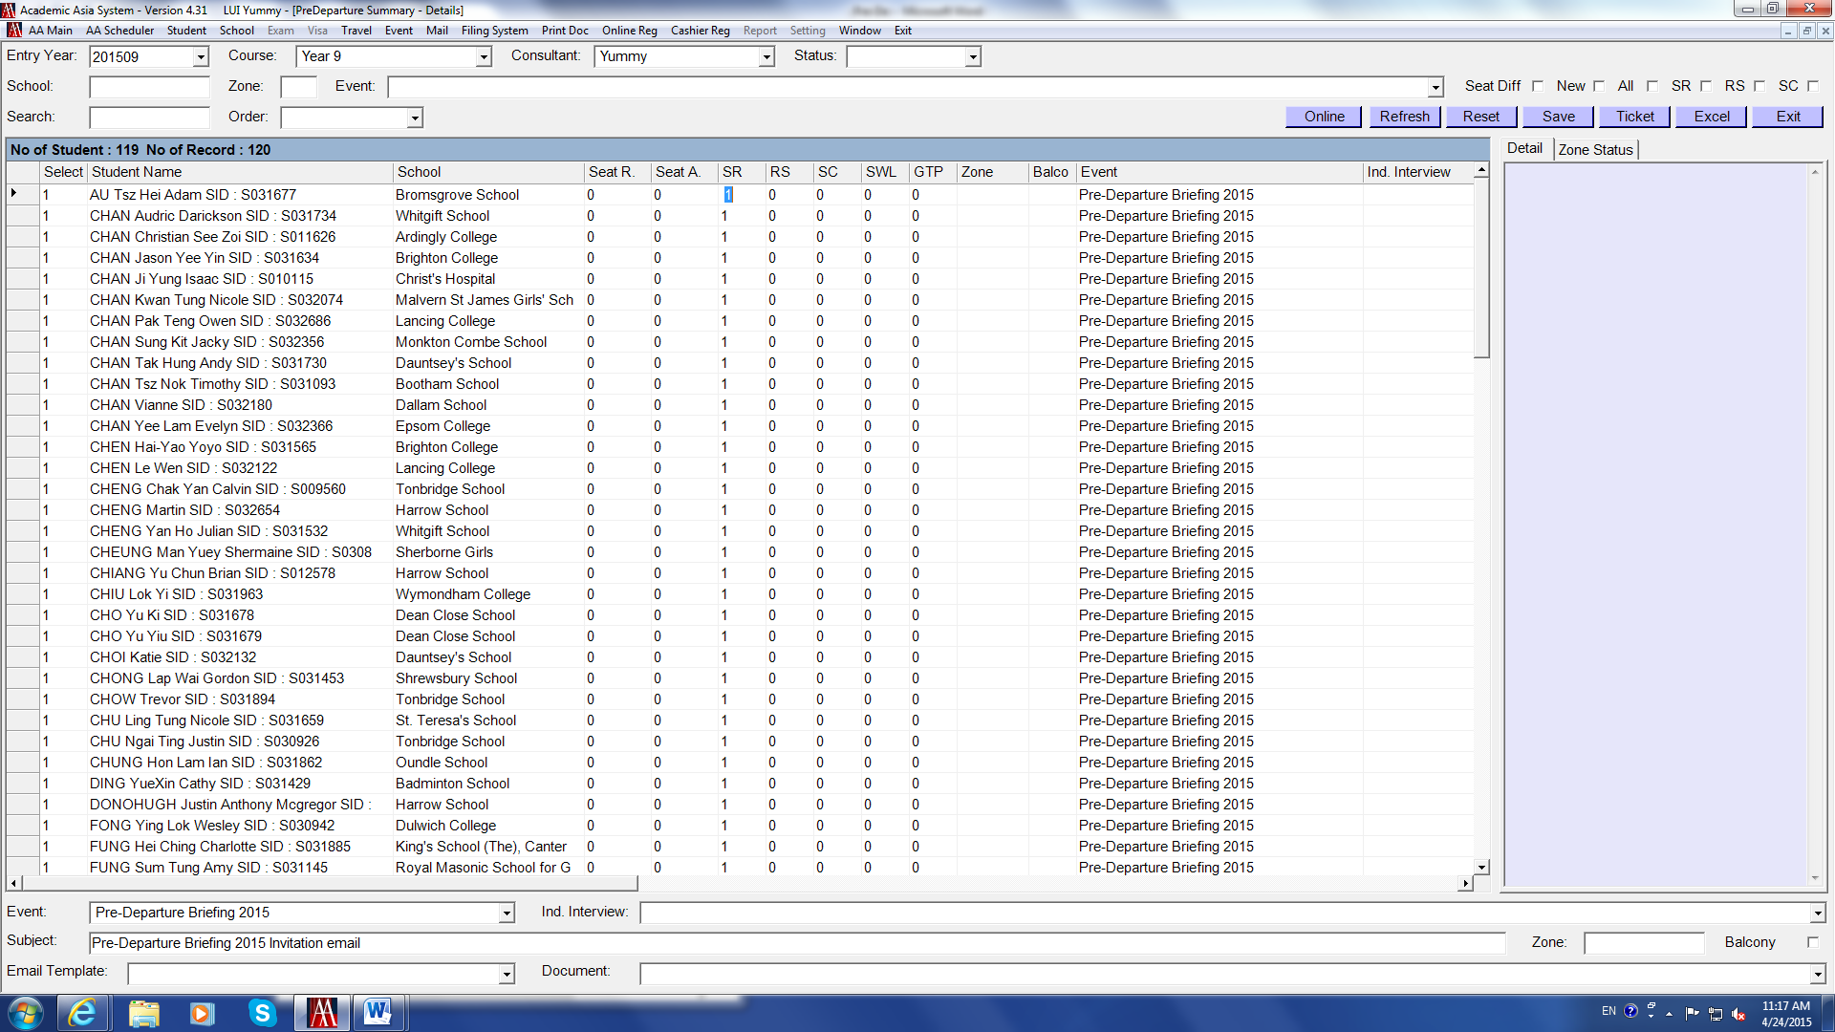

- Repeat the above steps to send invitation email to other year groups.
- AFTER SENT INVITATION EMAIL TO PARENT. SEND EMAIL TO AA STAFF SO THAT THEY ARE AWARE OF IT.

Send Invitation Email – after sending the first badge

Check Pre-Departure page daily to see if there is any new deposited students in order to send invitation.

- Open the Pre-Departure page, it shows NEW deposit by default, or tick New
- This is the list of students that have NOT done anything yet
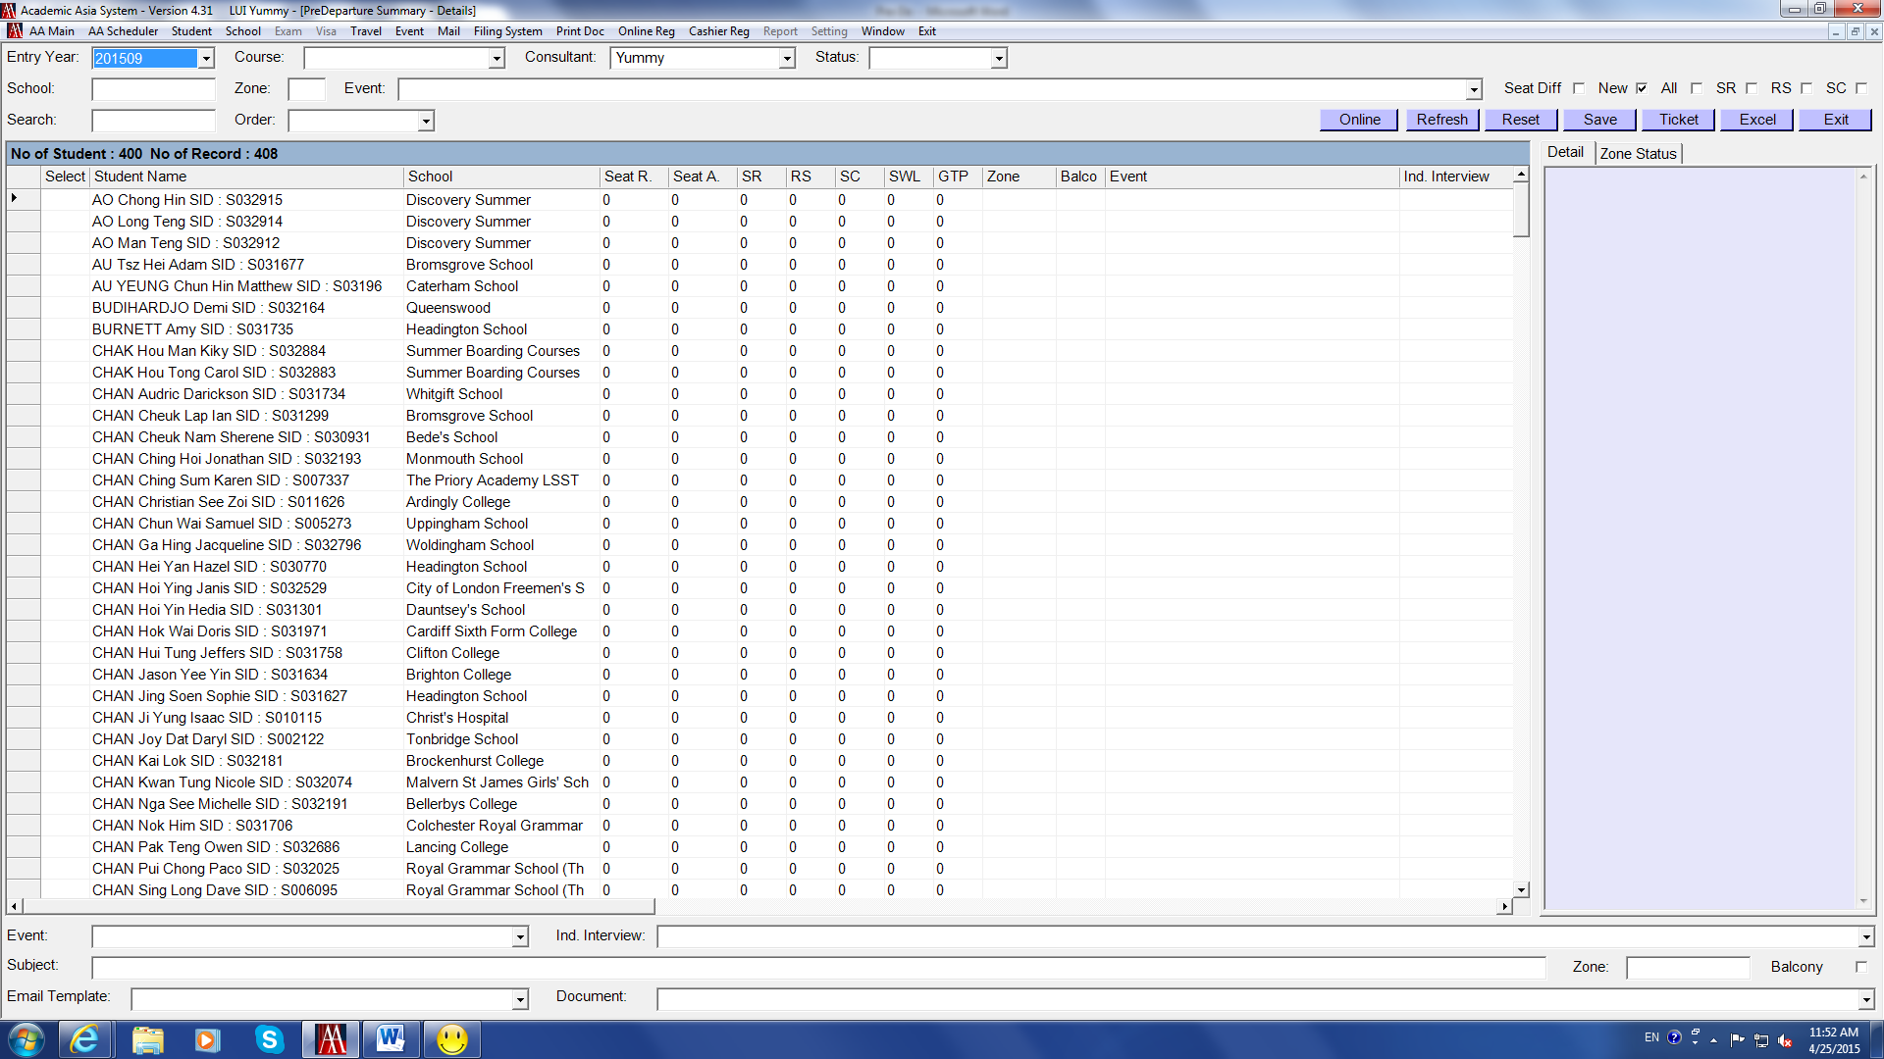

Repeat the above steps to add event:
- Right click choose Select All
- Unselect Drop, Summer Course, Referral, Living Overseas
- Update Event and interview

- Select Entry Year “201509” and Event “Pre-Departure 2015”
- Unselect all the boxes at the top right-hand corner.
- This shows the list of students who have NOT been sent invitation email yet
- Repeat the above steps to send invitation email in group
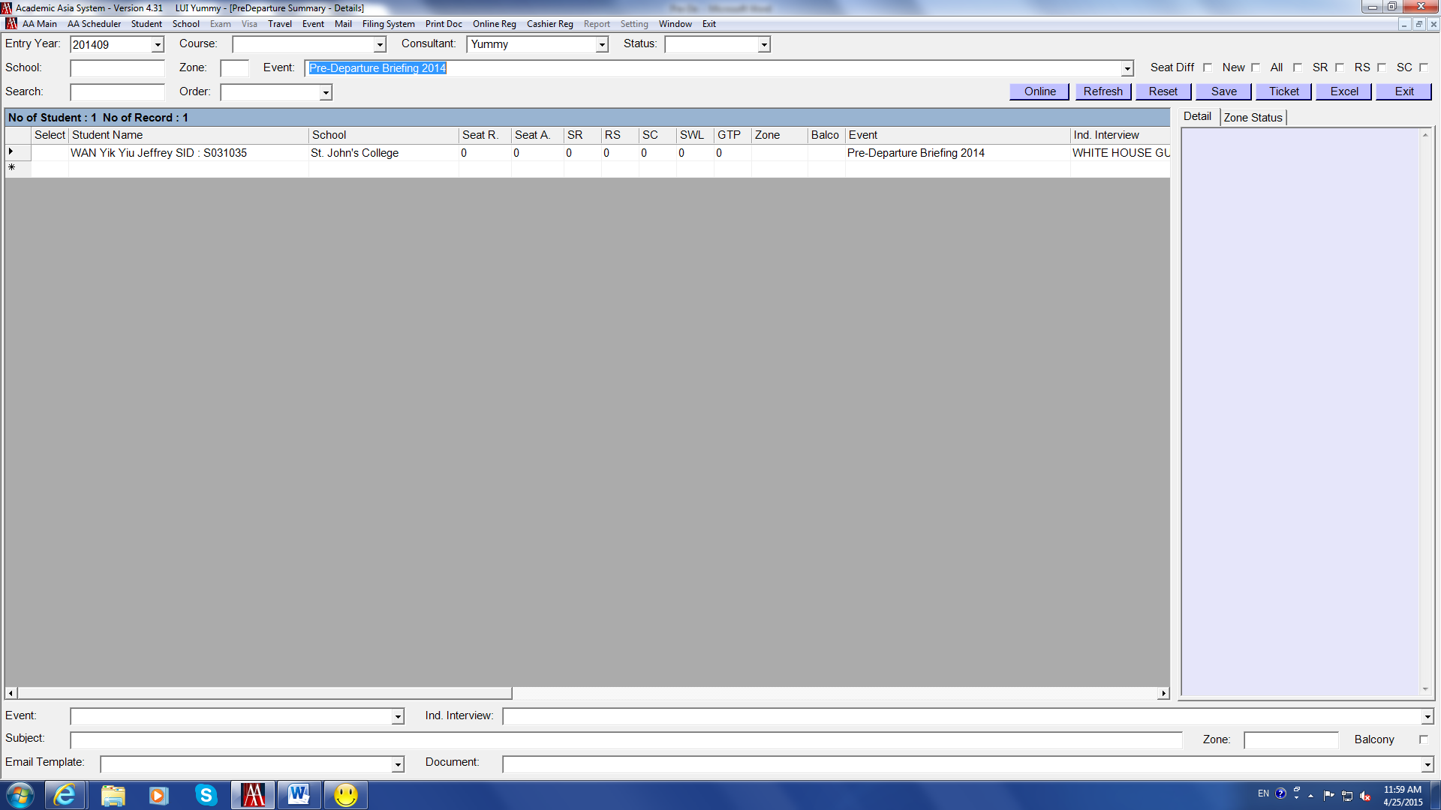

Send Invitation Email – after sending the first badge

Notes:

If there is only one or a couple of new deposited student/s on the list, we can send invitation email individually.
(but it is better to send by group mail)

- Double click the box on the left-hand side to select the specific student
- Select Event and Email Template, enter Subject at the bottom
- Right click choose Send Email
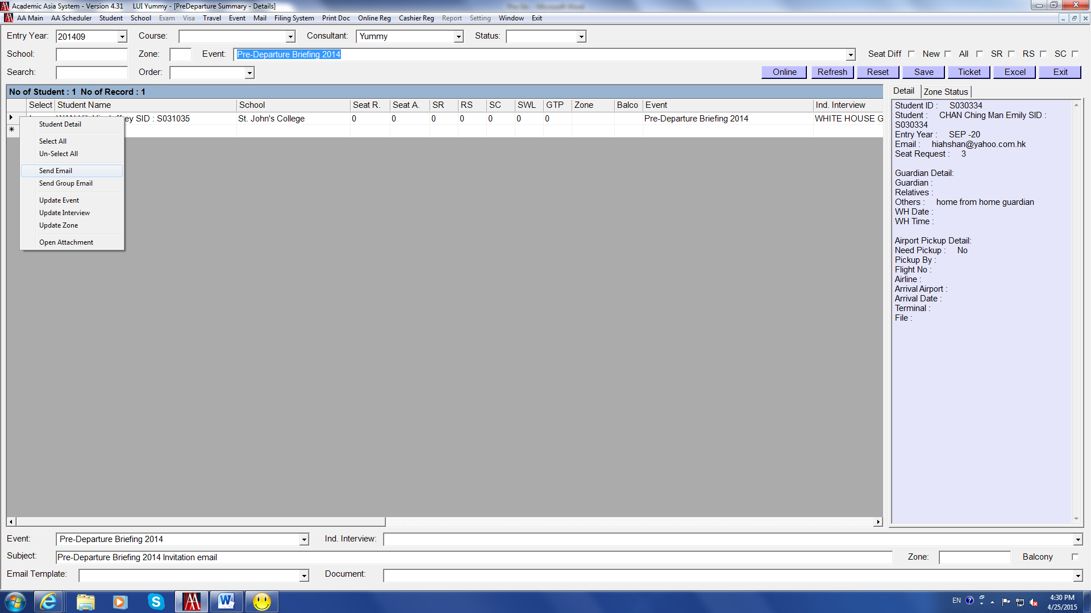

- Send E.Mail page comes up, check content and everything click Send
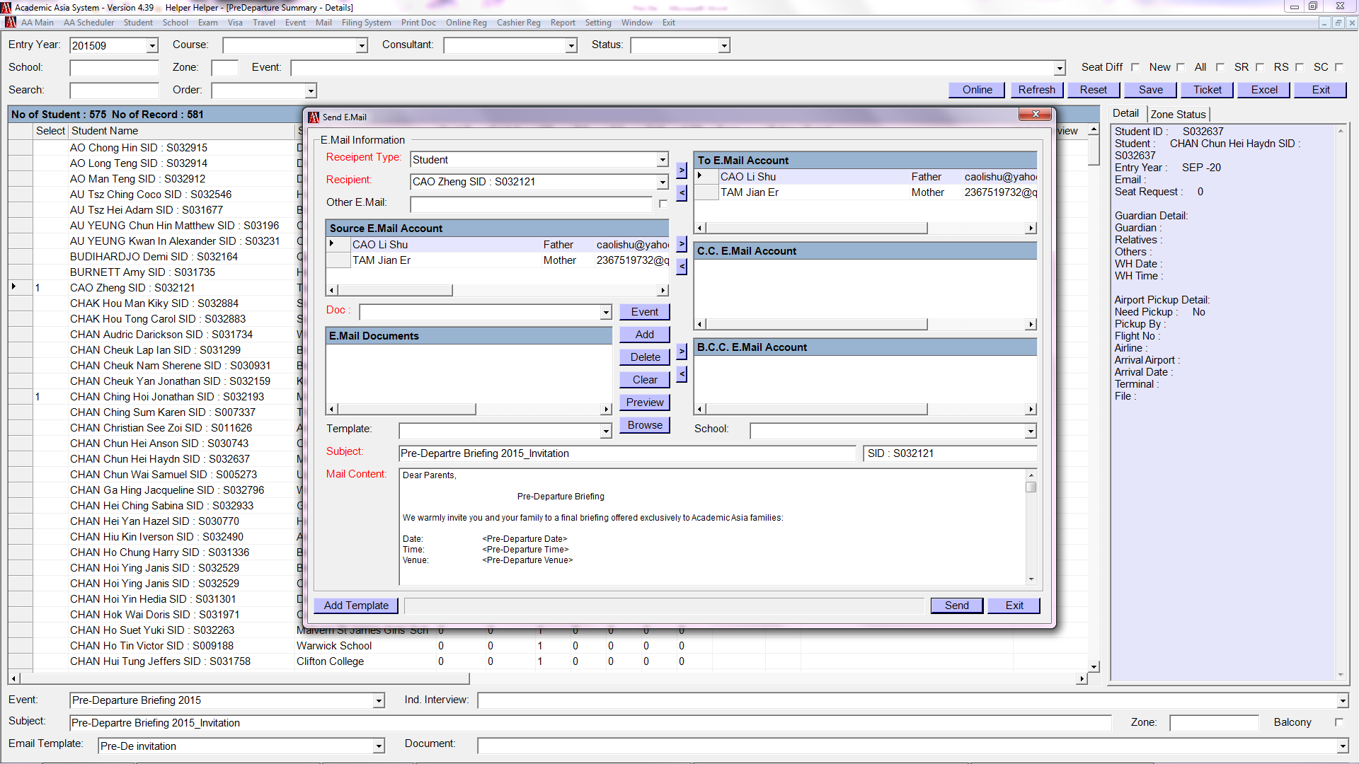

- The same as sending invitation email in group, go back to the Pre-Departure page, click Save

Update Online Registration Details

After sending invitation emails to the families, check system every day to see if there is any reply from the families.

- On the Pre-Departure page click Online at the top right-hand corner
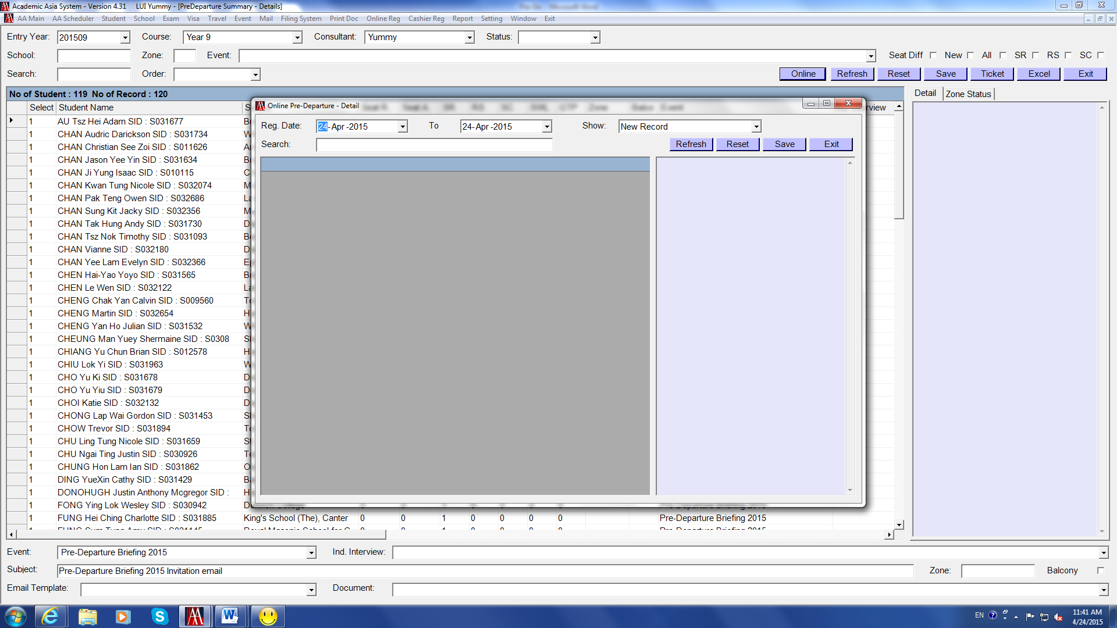

- The page displays all “New Record” by default, or we can select this in Show field
- This is the list of students who have done the Online Registration for joining Pre-De
- Click on EACH Student Name to see if there is any special/Chinese input, which may have to be enter in Student Profile manually
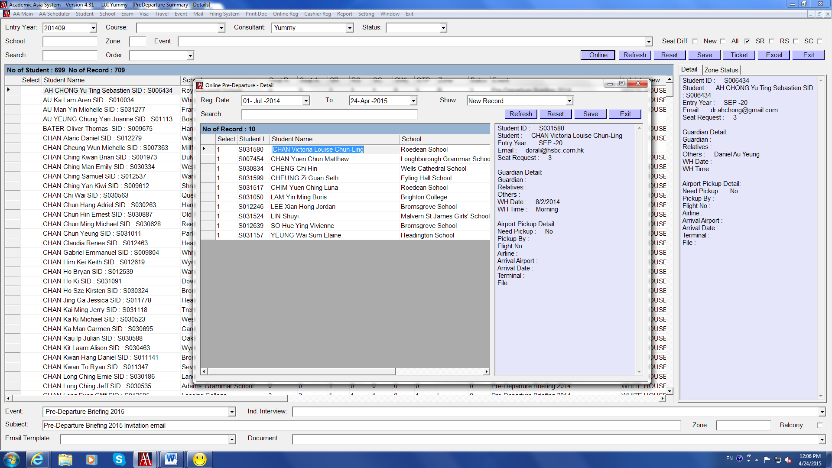
Update Online Registration Details (con’t)

After finishing the above checking:
- If there is duplicated record select the one which wants to be deleted, then click Delete
- Right click the box on the left-hand side choose Select All, then click Save
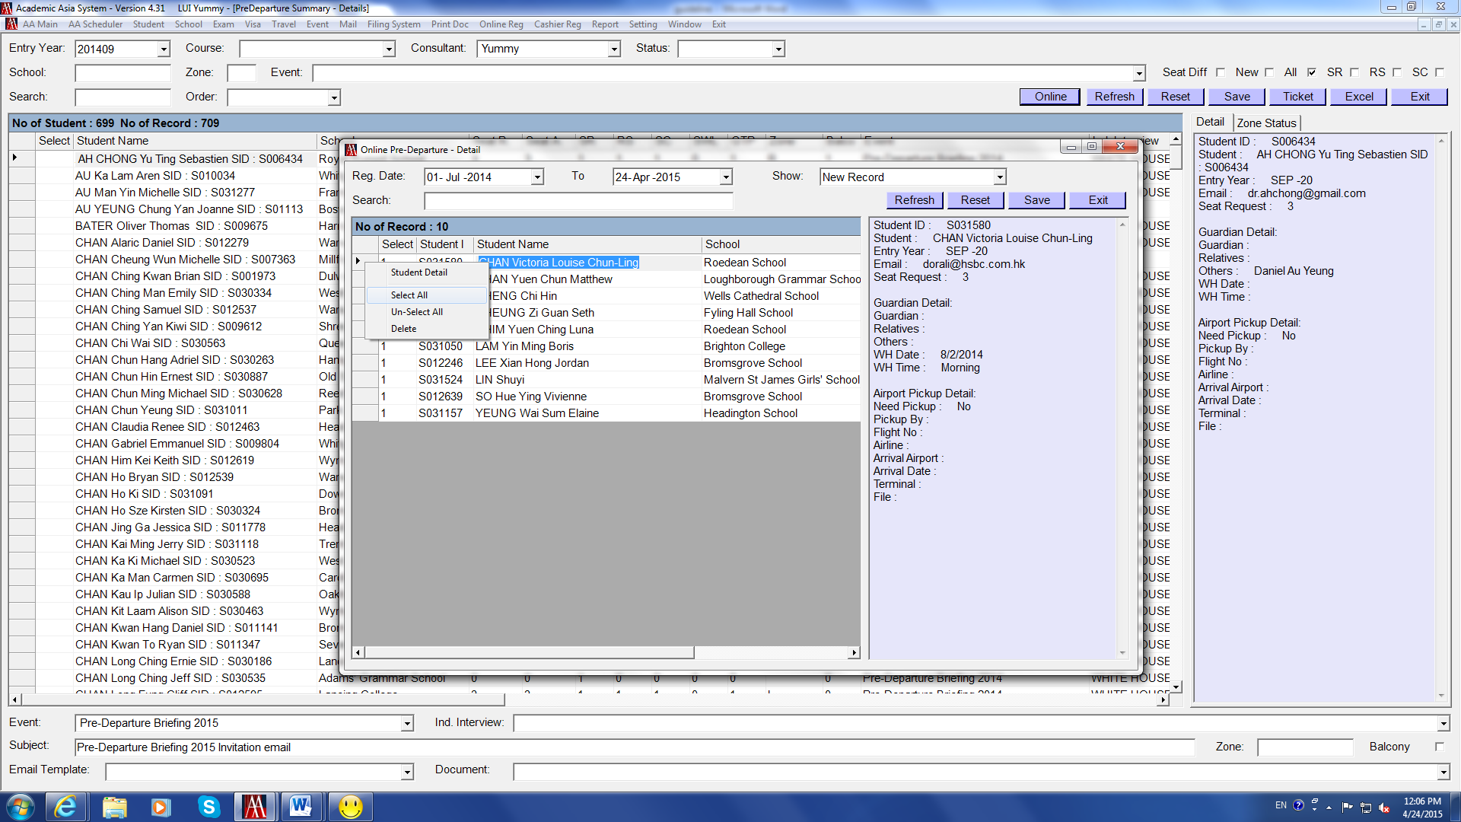

The above saved online registration details will be uploaded on AA System automatically.

- To get the list of students who have already registered online, tick SR + RS on Pre-Departure page
- When you click on the student name, the registered details will be shown in the box on right-hand side
- The SR and RS columns will be displayed with 1 and 1
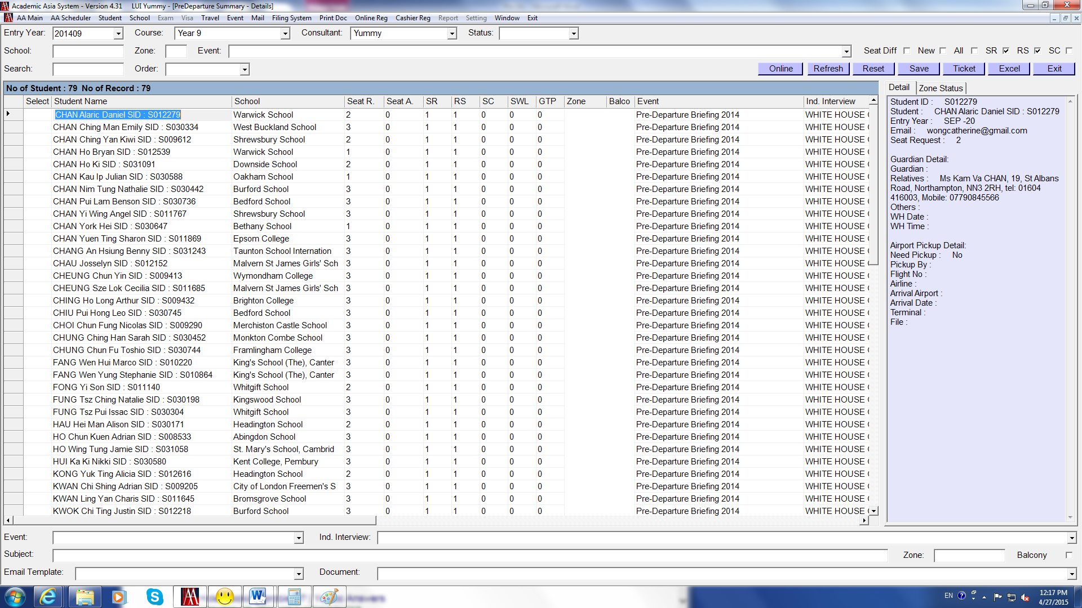

Update Online Registration Details (con’t)

Notes:

- On the Online Registration page, we can also check “Uploaded Record”, “Deleted Record”, or “All Record” by selecting Show field
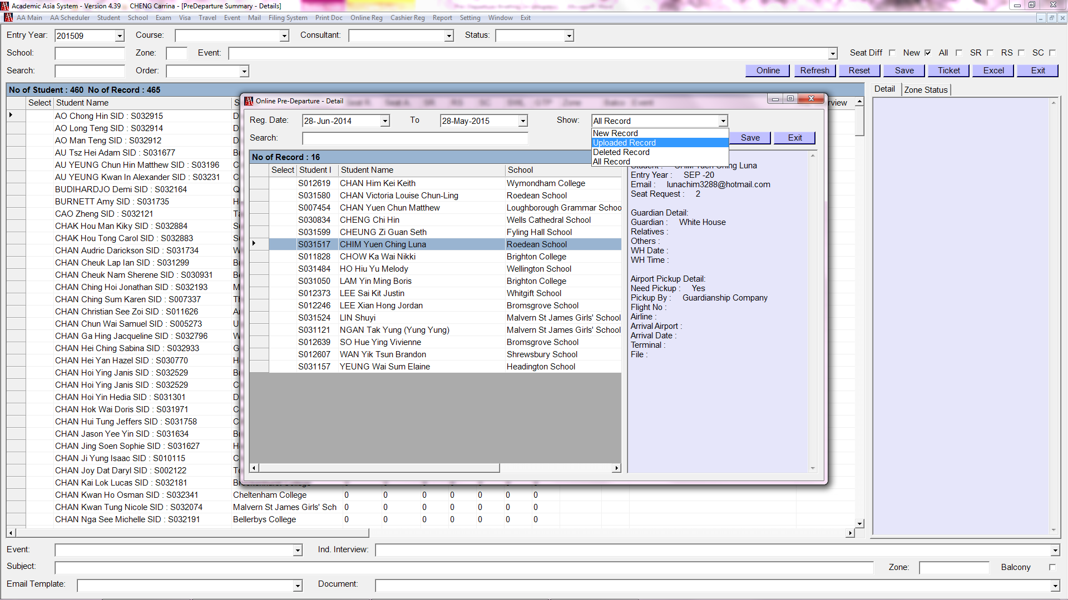

Assign Seats

- Tick SR + RS, now the Seat A column should be “0”


- Enter the number showing on Seat R column (means seat request) in Seat A column (means seat assign to the family)
e.g. CHAN Alaric Daniel SID: S012279 requests to have 2 seats as the Seat R is “2”, enter 2 in Seat A to assign 2 seats for this family.
- Click Save after doing the badge
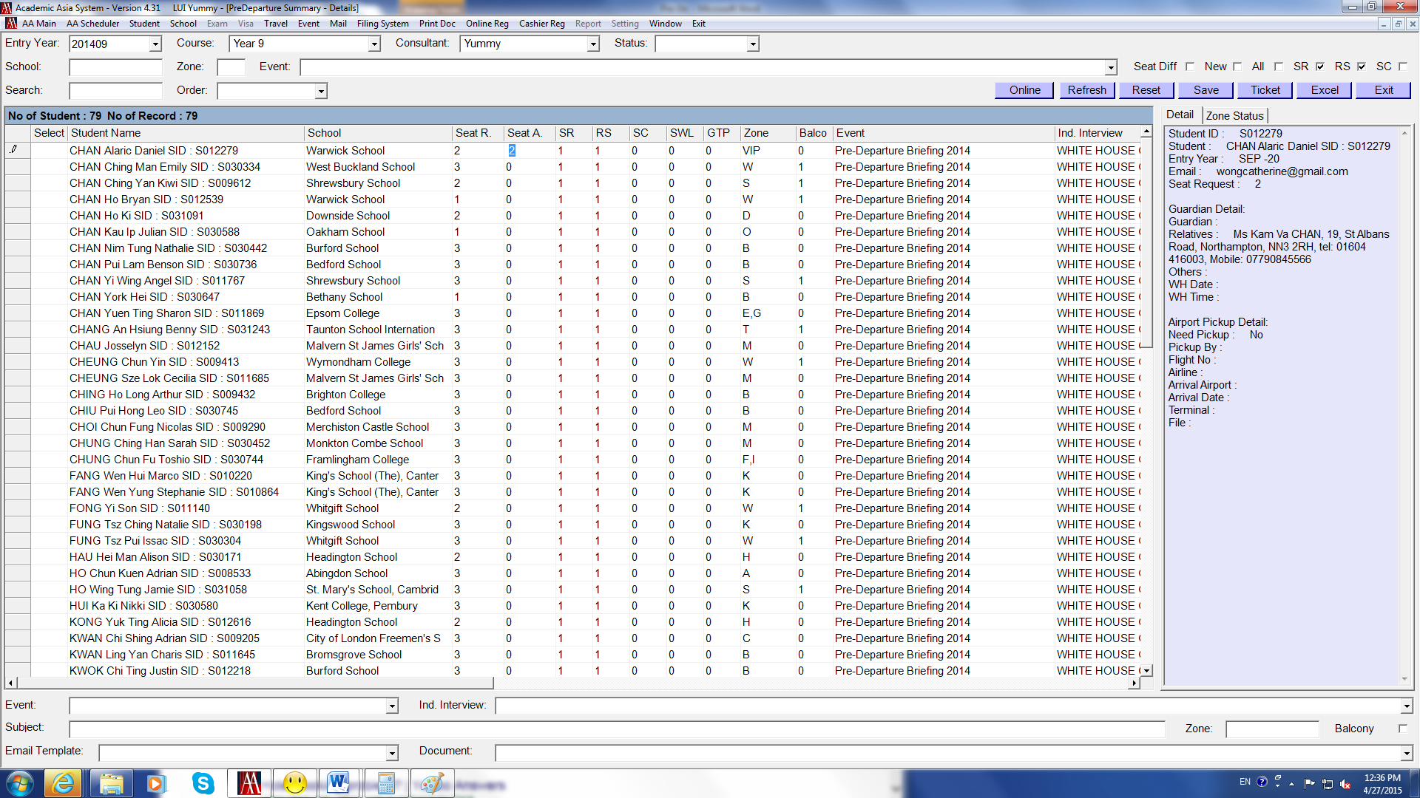

Assign Seats – after doing the first badge

Tick SR + RS | Students who have done the Online Registration
Tick Seat Diff + SR + RS | Students who have done the Online Registration  and  NOT yet assigned seats

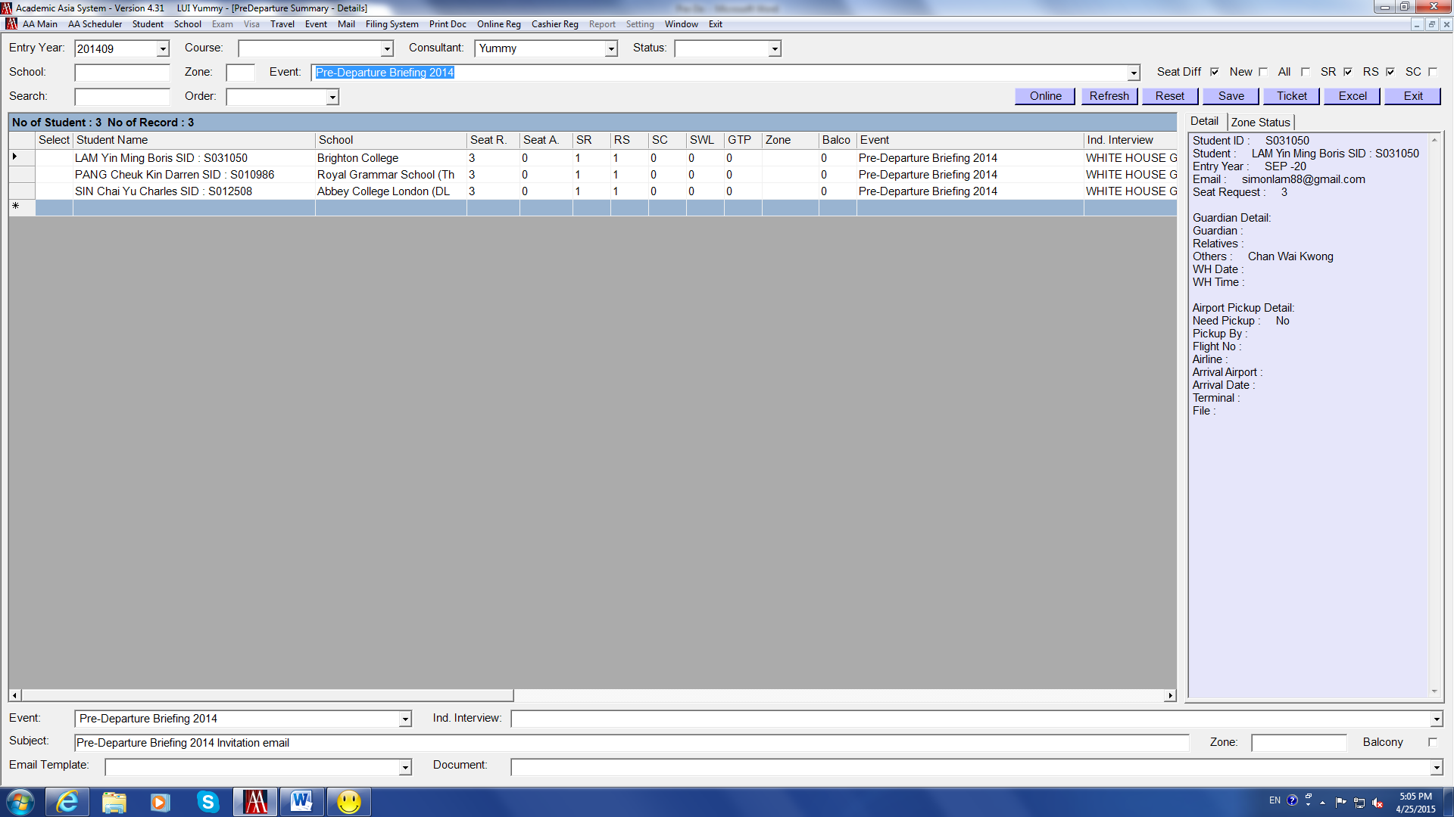

Notes:

We offer max. 3 ticket to each family. Some families may ask for extra ticket/s. Usually we can make a note and will only be able to confirm whether or not we can offer the requested extra ticket/s nearer the time.

- Make a note in the Remark column on the Pre-Departure page click Save
- If this can be assigned, edit the number in Seat A column (NO need to change the Seat R column)
- Click Save
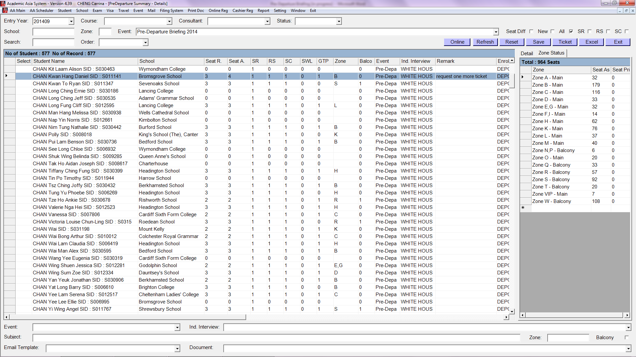
Assign Zones

Zones are assigned according to schools’ name (the first letter of the school name that student has deposited).

Do this in group:

- We can also assign zone by using same method as updating event
- Make necessary selection at the top Enter an alphabet in School click Refresh, a list of school starting with the same letter comes up
- Enter the same alphabet in Zone at the bottom of the page
- Right click a box on the left-hand side right click choose Update Zone
- If need to delete Zone Letter, press “Backspace” press “Space”
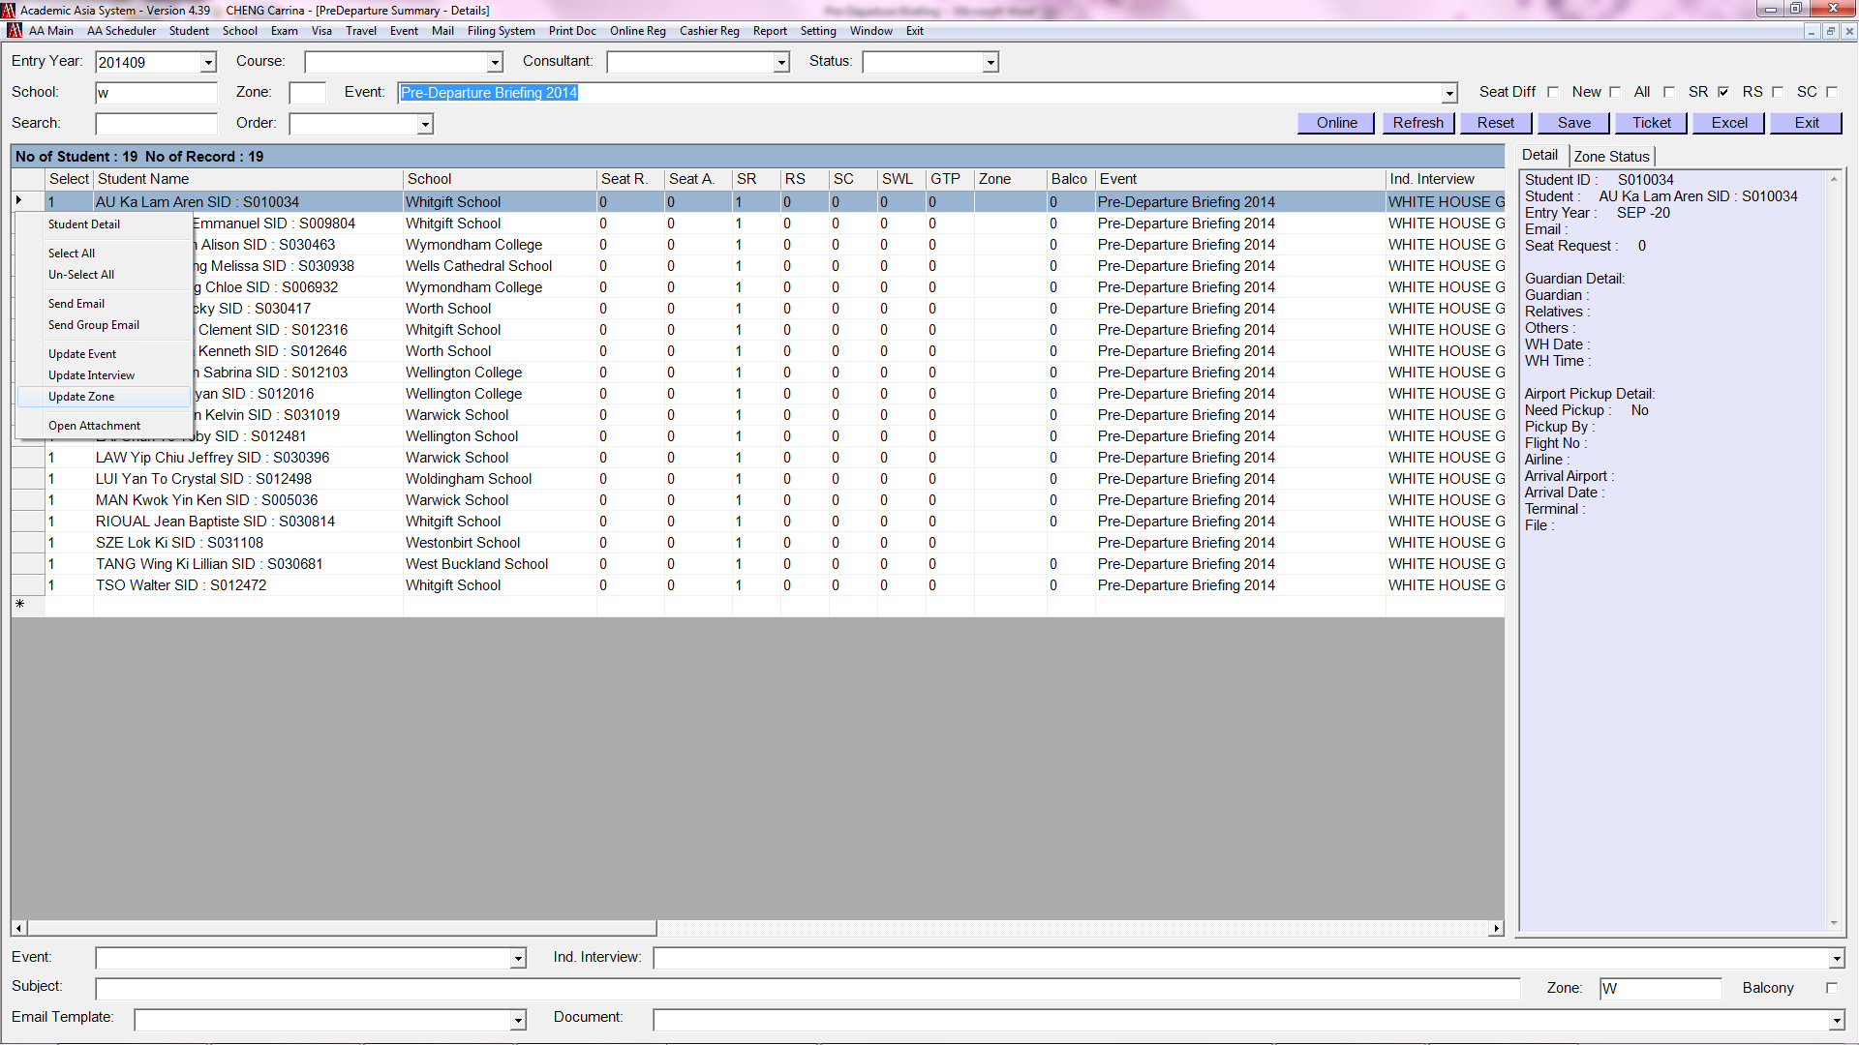

- The alphabet which we have entered in Zone is now appear in the Zone column
- Click Save
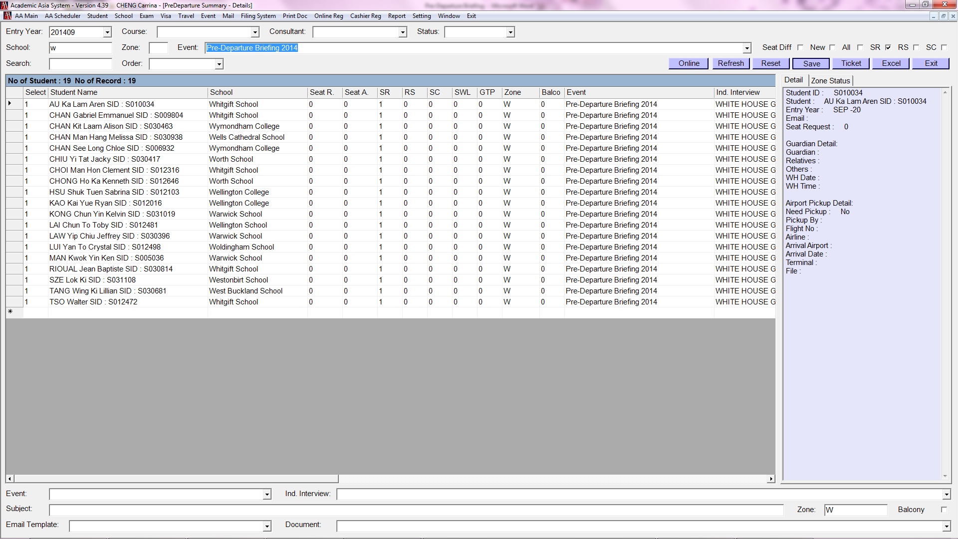
Assign Zones (con’t)

Do this individually:

- For example, put “W” in Zone column if the student is going to West Buckland School, “S” in Zone column for Shrewsbury School
- Click Save after doing the badge
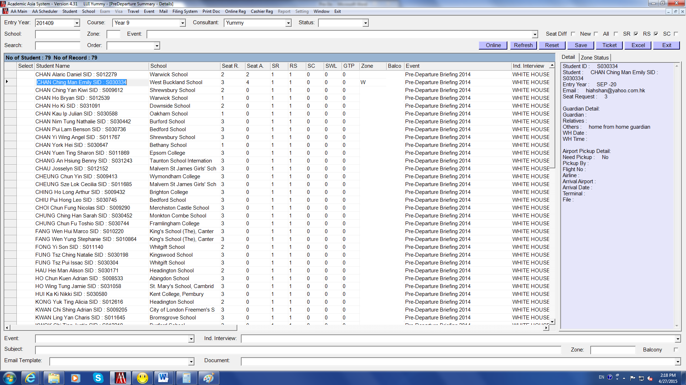

Assign Floor

We can also assign floor individually or in group.

Do this individually:

- Tick SR and make necessary selection at the top of the page
- The same as assigning floor, enter “1” in Balcony column
- No need to do anything for those zones in Main Auditorium
- Click Save
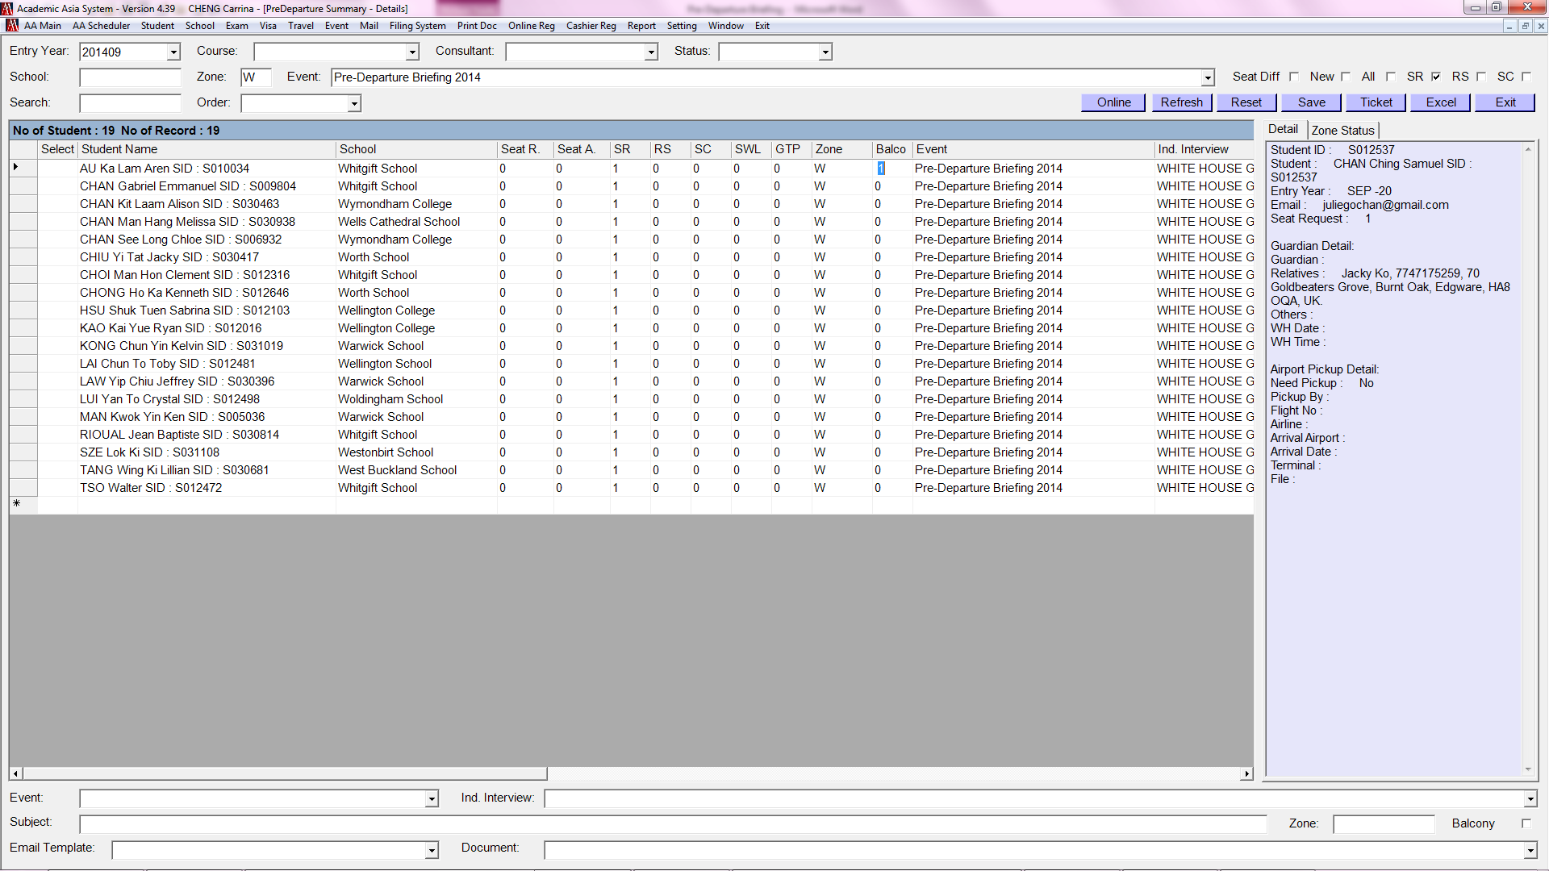

Do this in group:

- Make the same selection as the above
- Enter the zone alphabet in Zone and tick the Balcony box
- Right click a box on the left-hand side right click choose Update Zone
- “1” will appear in the Balcony column click Save
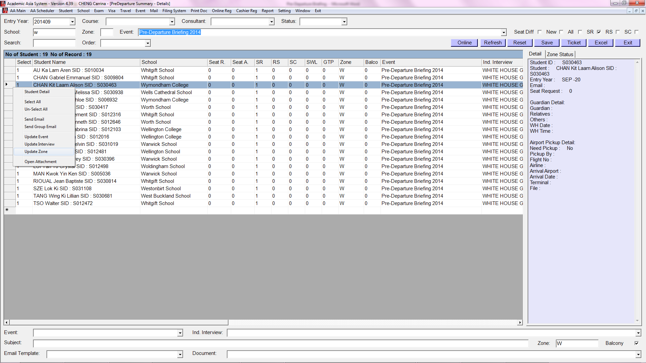
Send Confirmation Email

- We are required to send confirmation email to families within 4 working days
- Make sure we have enough seats before sending confirmation
- Try to send confirmation email in badge

- Check the number of assigned Seats in Zone Status box before sending confirmation
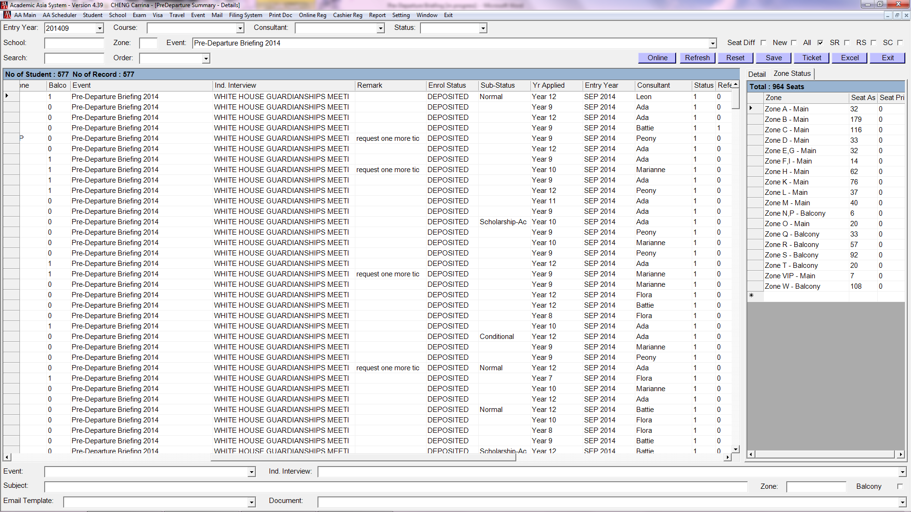

- Select Event “Pre-Departure Briefing 2015”
- Enter Subject, select Email Template [Confirmation email], set up email template using previous template, select Document (if any)
- Right click a box on the left-hand side choose Send Group Email
- Repeat the above steps for sending invitation email in group
- Click Save after sending the group of confirmation email, “1” will be display in the SC column, which means this has been done
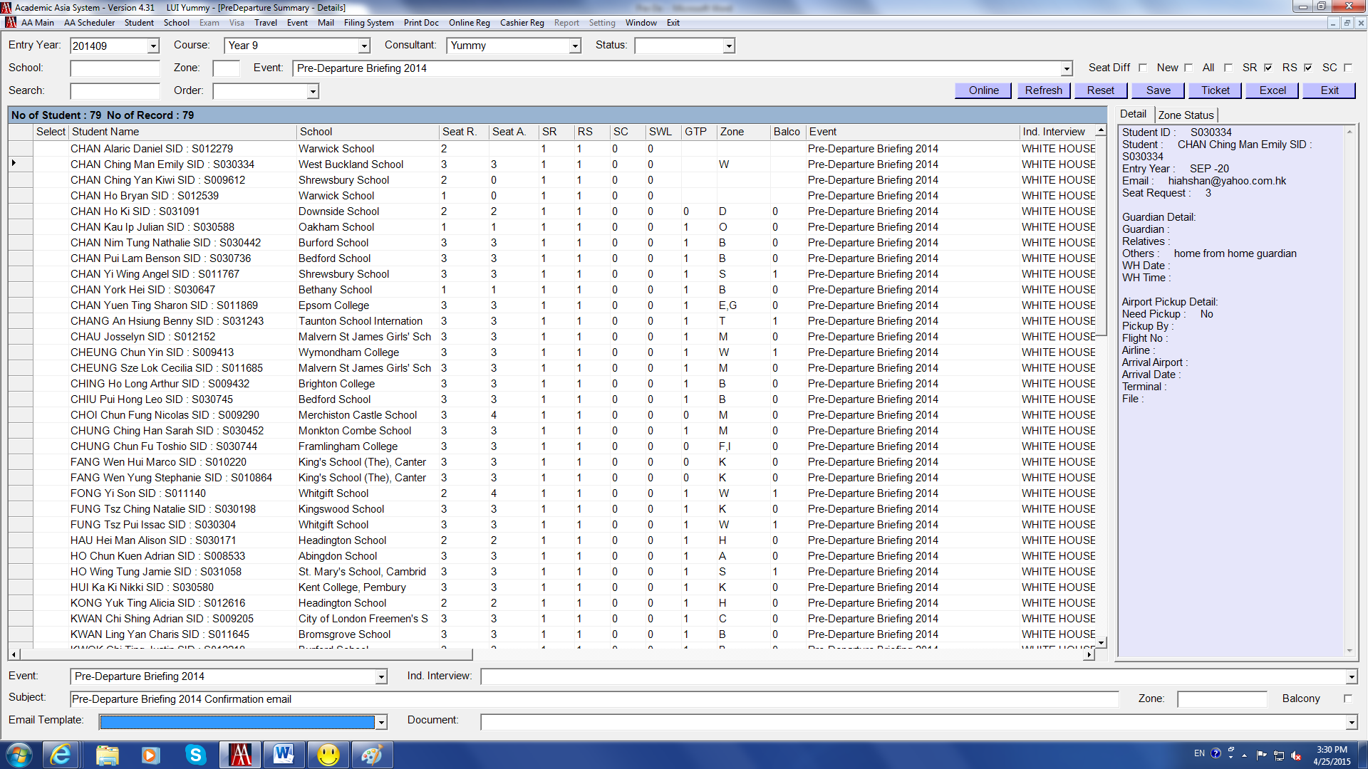

Send Confirmation Email (con’t)

- Tick SR + RS + SC to see the list
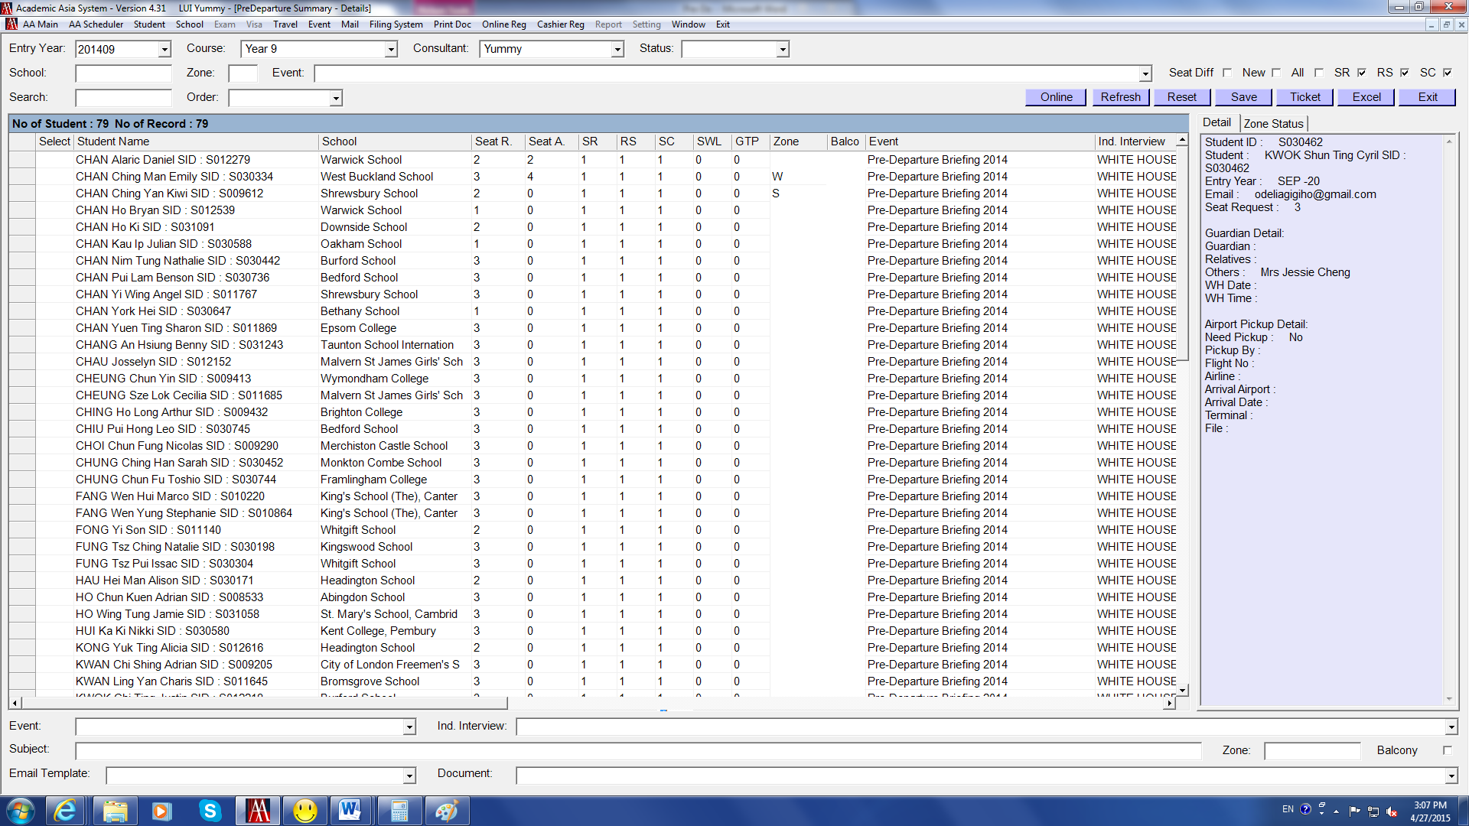

Prepare the Ticket Pack (Admission Pack)

Steps to prepare the Ticket Pack:
- Count the number of seats
- Draw the Seating Layout Plan
- Print tickets
- Prepare student label
- Collate the ticket pack documents
- Inform families for the collection of ticket pack
- After families collection of the ticket pack

- Prepare the Ticket Pack – Count the number of seats

- To count the number of seats required at each zone, enter different alphabets in the Zone column to add up the total number of seats required at each zone
i.e. put “A” in all the school names starting with “A” here
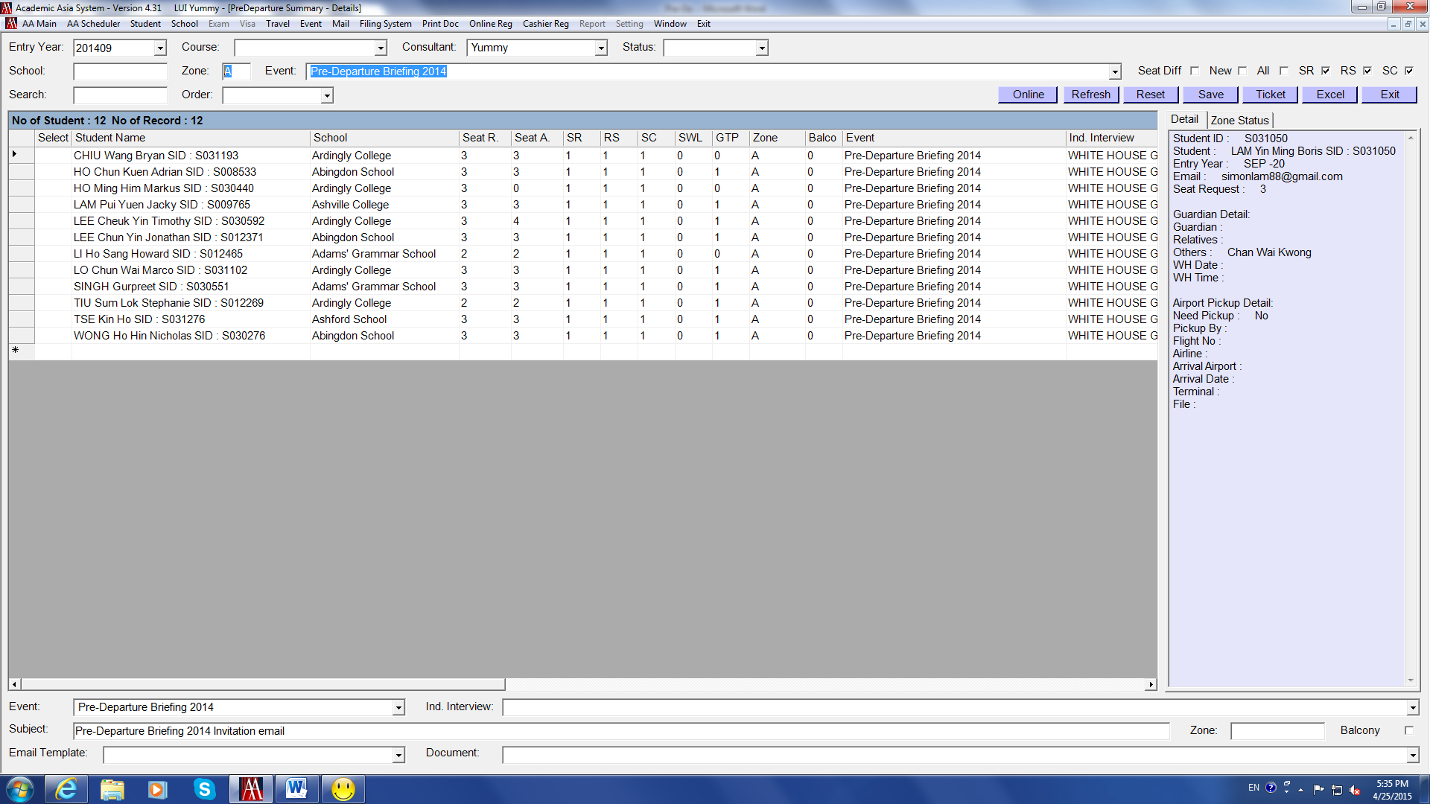

- Check the Zone Status to see the number of seats required for each zone
e.g. Seat Assign in Zone A showing “32”, so that total seats assigned at Zone A will be around 32
Usually we require some spare seats for each zone. The final seats of Zone A would be 40 or 45 seats (Depends on the size of area and the chance of having more deposits for schools in a zone)
- Repeat the above steps for the rest of the alphabets


- Prepare the Ticket Pack – Count the number of seats (con’t)

However, some zones may require fewer seats
e.g. “F” requires 11 seats only and “I” requires 3 seats only
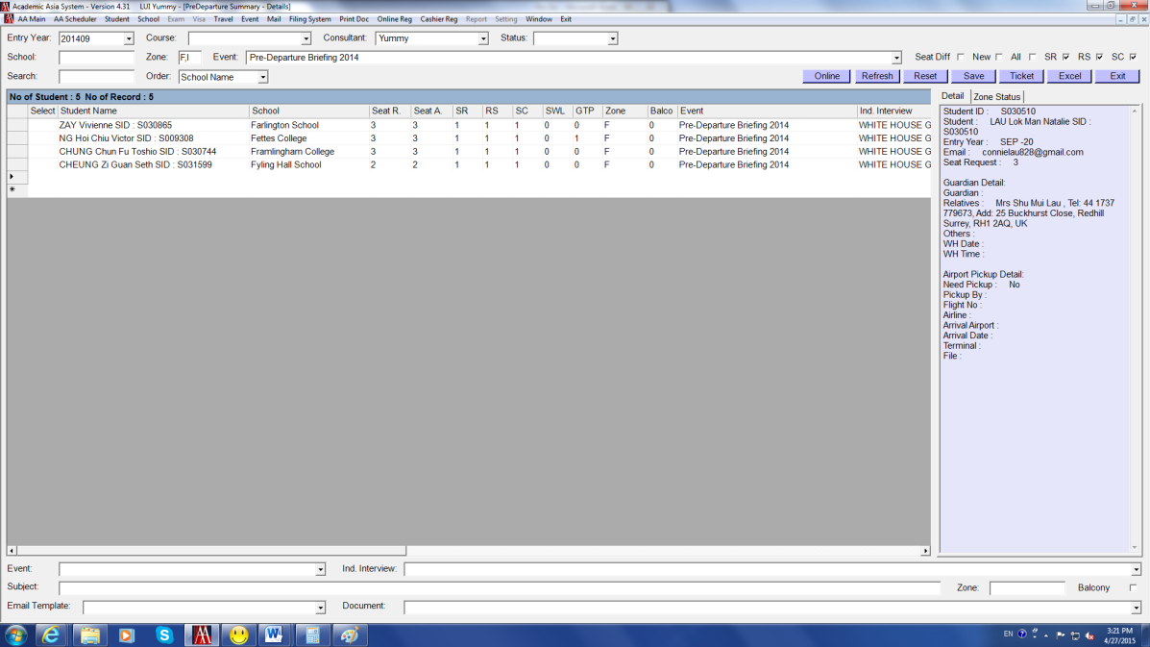
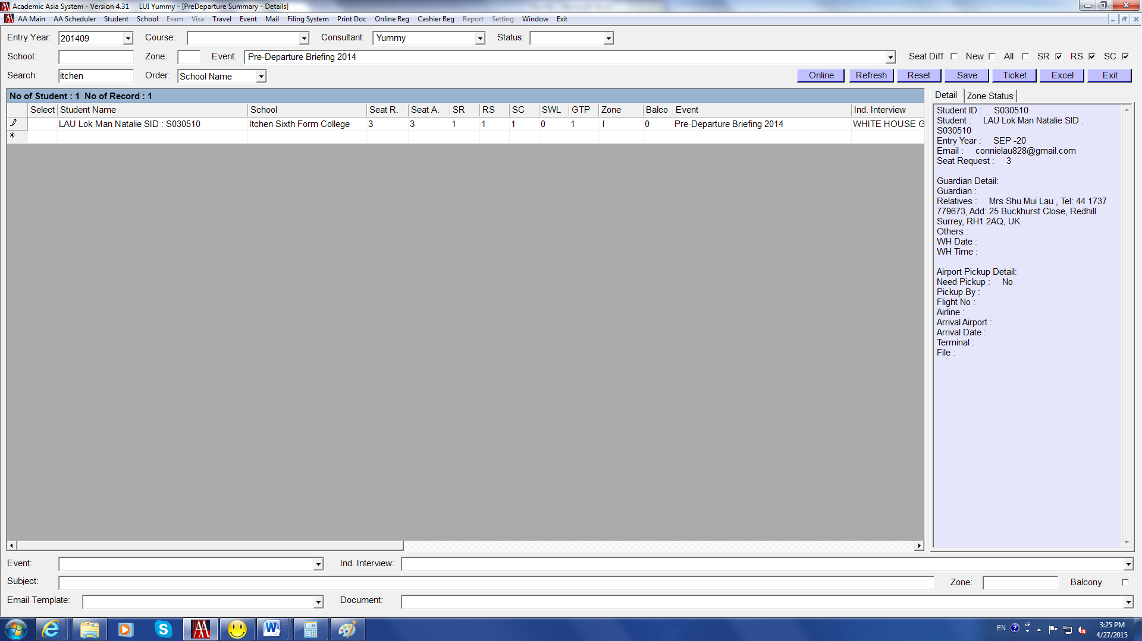

- In this case, combine these two alphabets in ONE zone
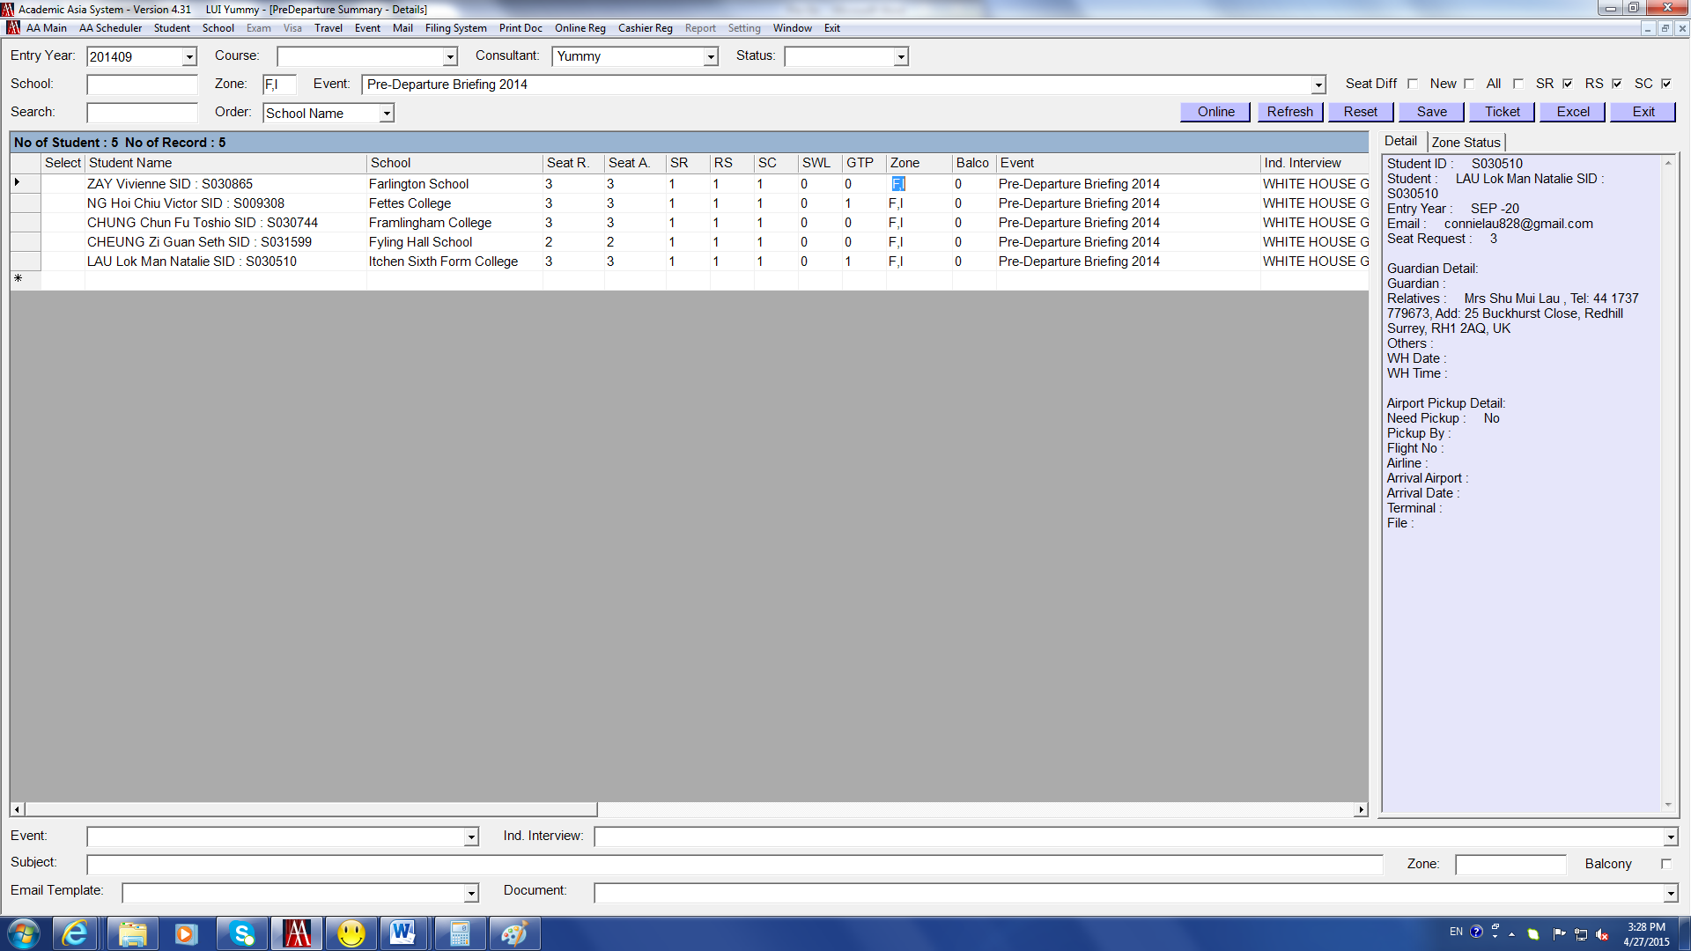
- Prepare the Ticket Pack – Draw the Seating Layout Plan

- The updated (blank) Seating Layout Plan is filed on Filing System
AA FOLDER\PreDeparture\2015\Venue- PolyU
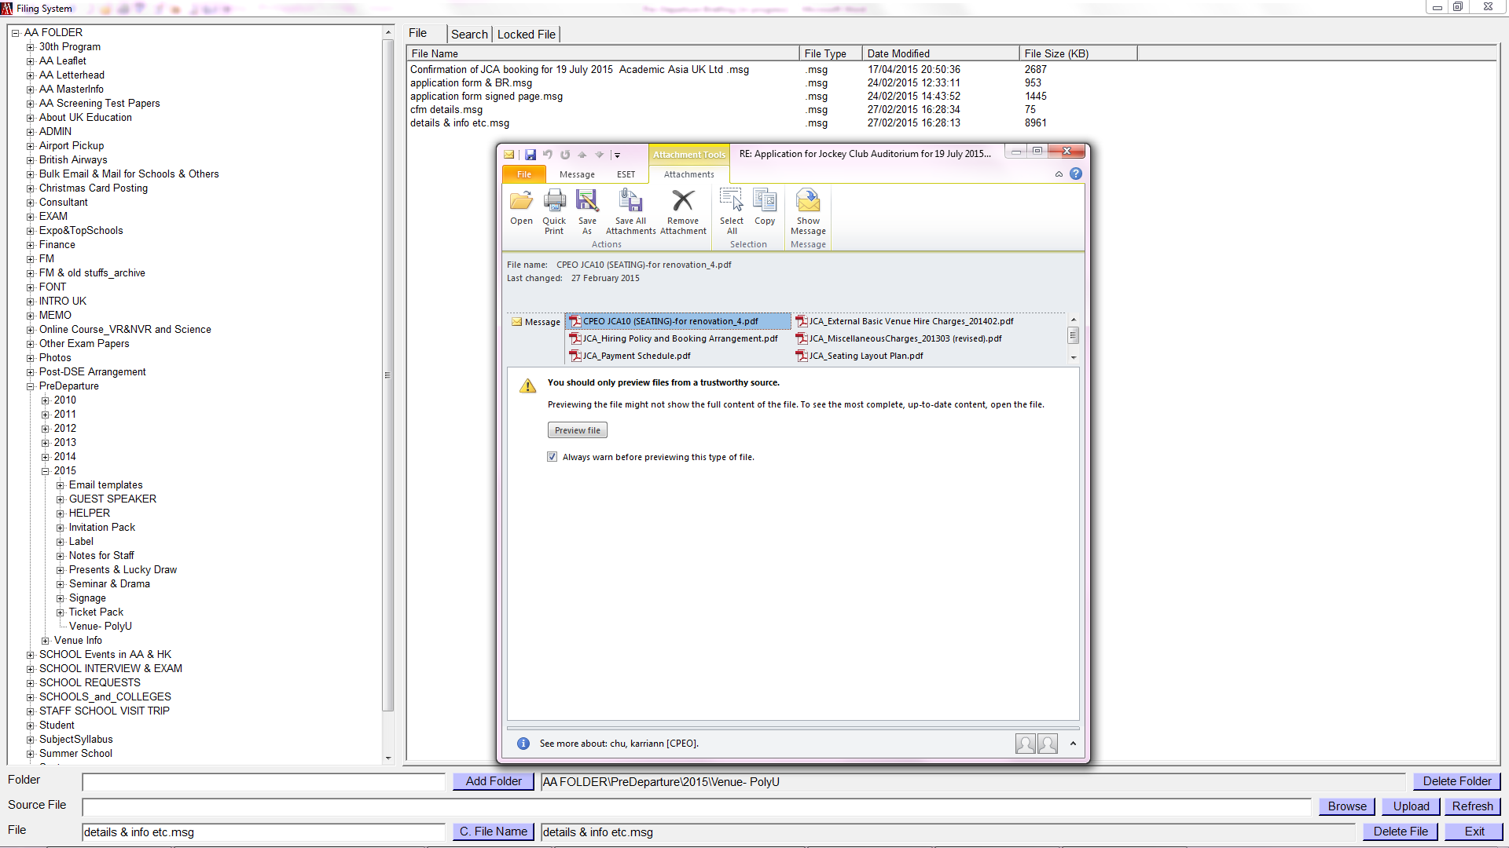
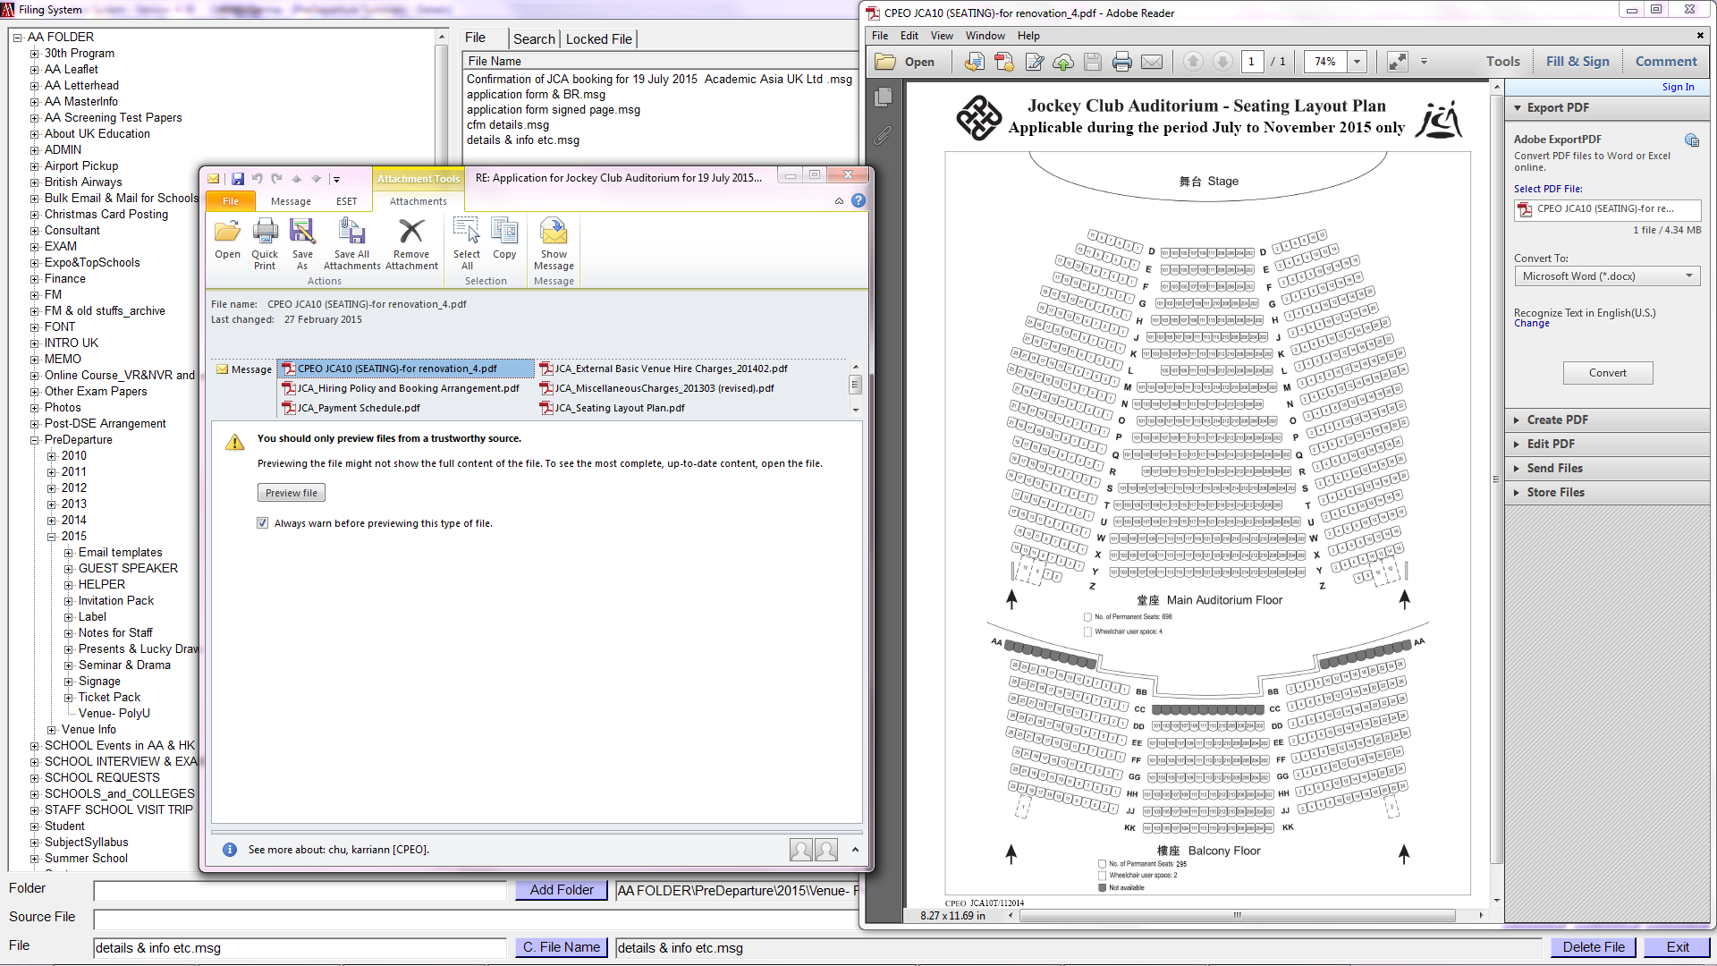

- Divide the size of each zone and draw a new seating plan with alphabets like this
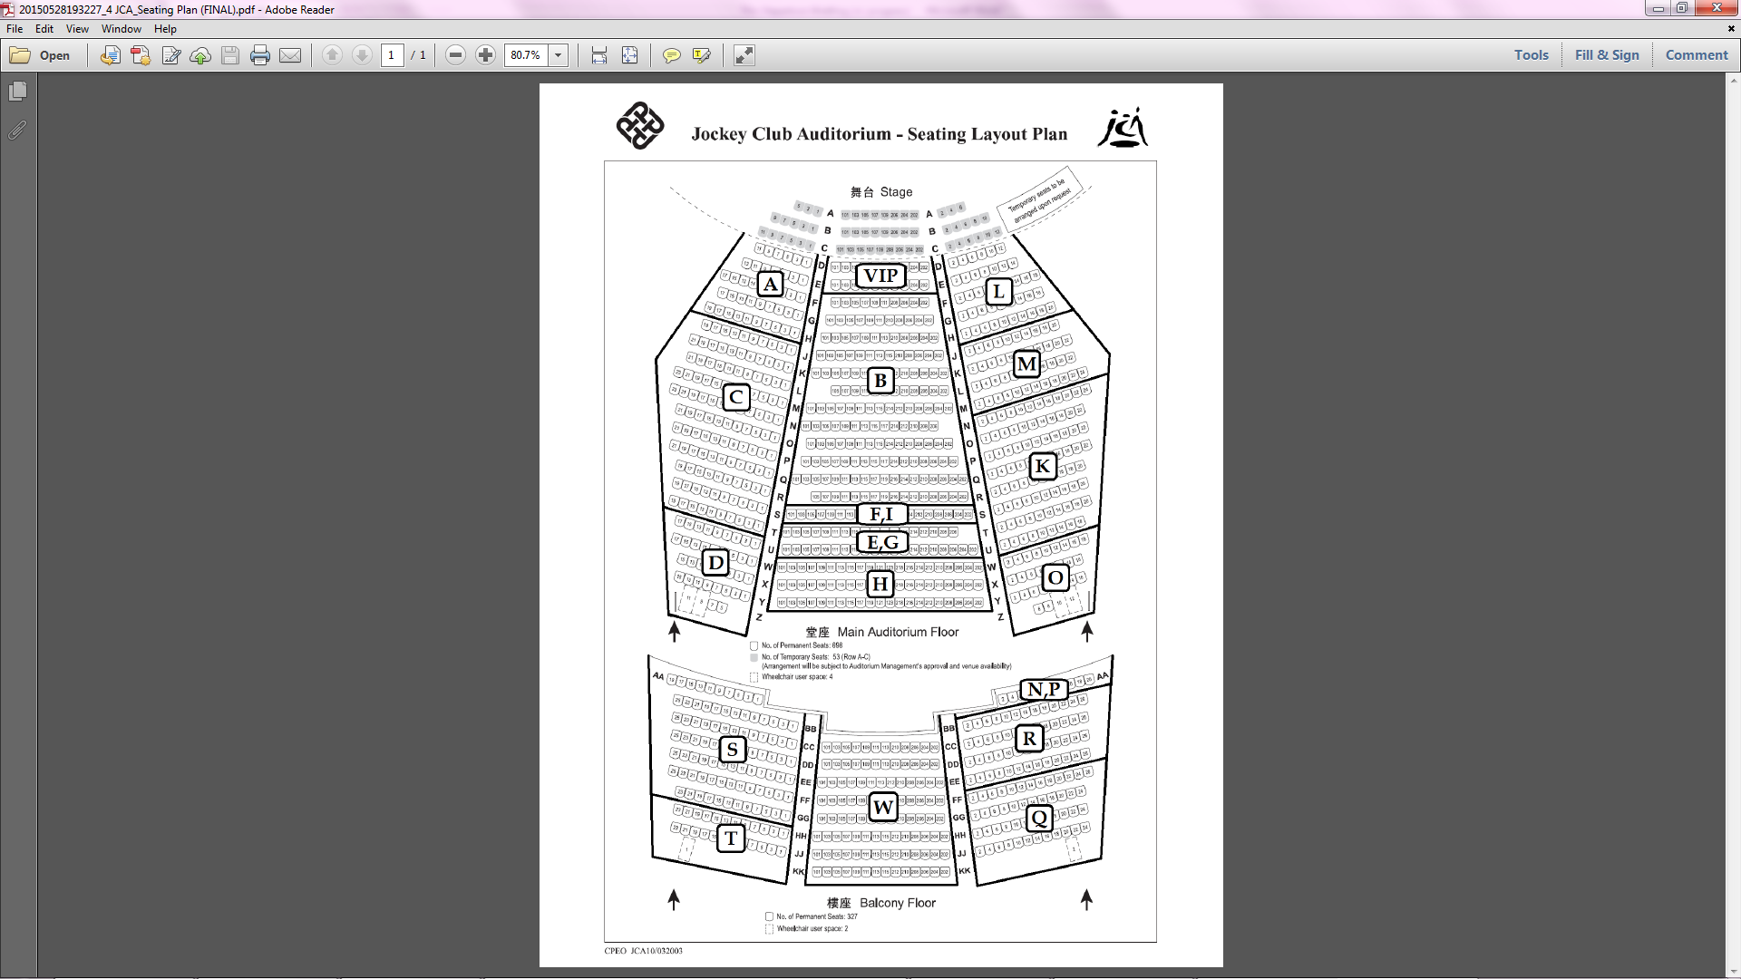
- Prepare the Ticket Pack – Print Tickets

- Tick SR + RS + SC to cross check the list of students whose seats have been assigned
- Seat A column – make sure the number are correct and no missing
- Balcony column – put “1” for those zones arranged on Balcony; “0” for zones on the Main Auditorium
Click Save
- Enter the number of tickets to be printed in the Seat Print column according to the Seating Layout Plan, see “Zone A” in below as an example
- Click Ticket to generate the ticket in Excel file
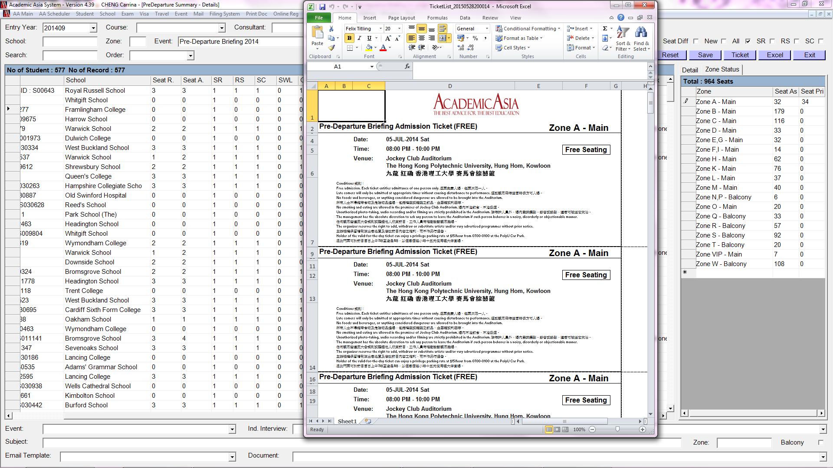

- Select “HP LaserJet M1530 MFP Series PCL 6” printer for printing
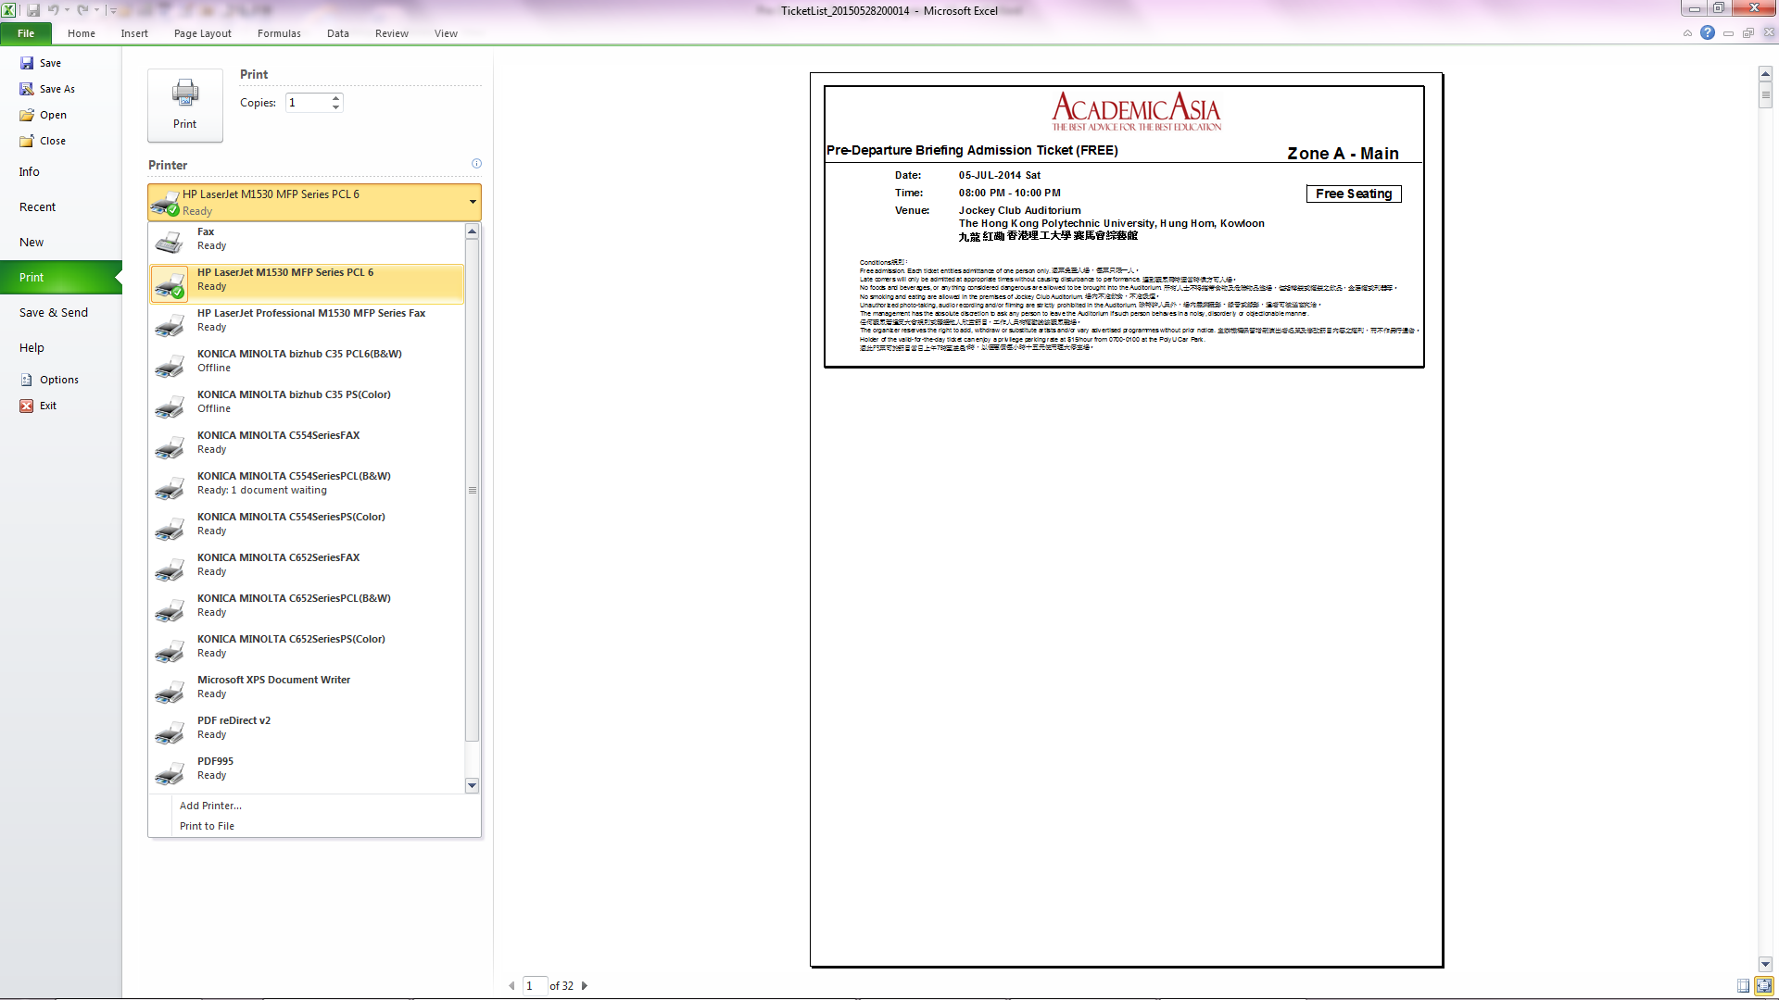

Notes:

- Tickets are usually printed on light blue paper which is in 1/3 A4 size (can order from M1)
- Try to print tickets per alphabet for easy management
- Print this on plain paper for testing beforehand
- Send the tickets to PolyU for stamping (together with signage on campus) once these are ready
- Prepare the Ticket Pack – Prepare Student Label

Print the Student Name Label, Lucky Draw Card label, and Label on Collection Envelope for every students who will join the event

- At the top, select Entry Year “201509” and Event “Pre-Departure Briefing 2015”, tick SR + RS + SC
- Click Excel, it takes sometimes to generate the list
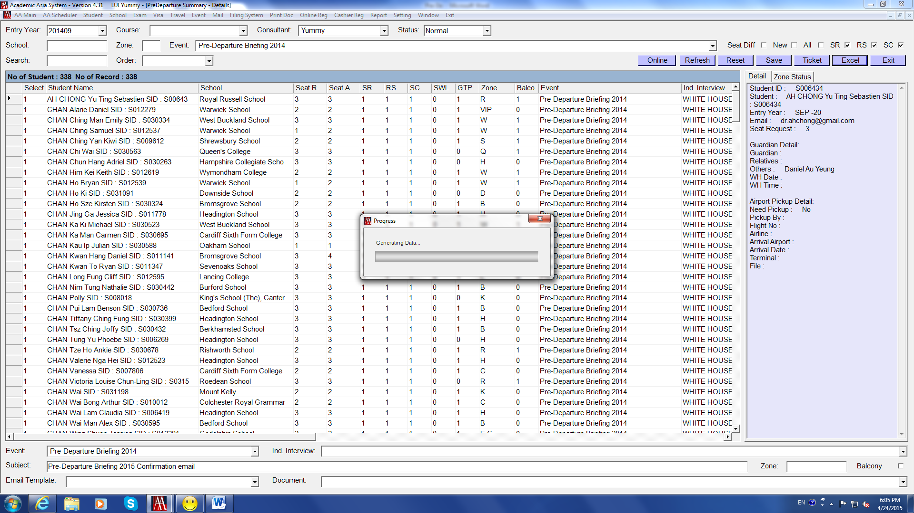

- The list is in alphabetical order of students’ surname
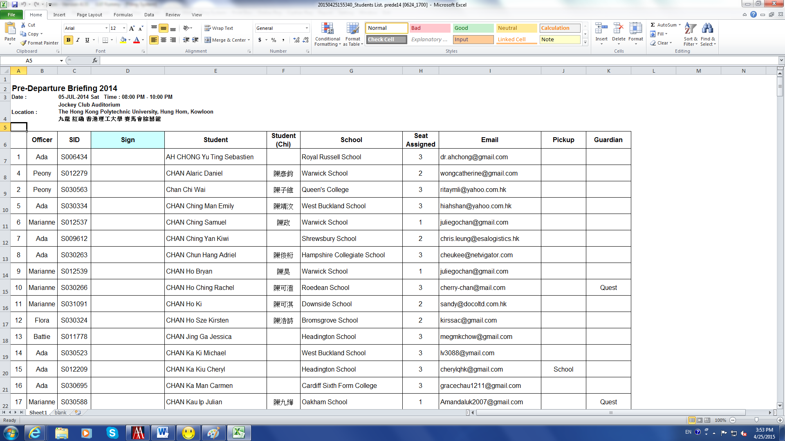

Prepare the labels by using Mail Merge:
- Method of preparing the mail merge template
Filing System AA FOLDER\ADMIN\Labels @ Using Mail Merge on Excel & Word doc
- Templates of 2014
Filing System AA FOLDER\PreDeparture\2014\Label

5. Prepare the Ticket Pack – Collate the ticket pack documents

Ticket Pack includes the following items:

Big clipped
- Lucky Draw card with students' & schools' names [3x8 label]
- Name Label with students' & schools' names [2x8 label]
- Ticket/s [light blue 1/3 A4]
- Seating Layout Plan [white A4]

In a blue clear file
- Cover letter [AA letterhead] (different cover for little actors – see 2014 template for reference)
- Programme Rundown [green A4]
- Pre-De Checklist [yellow A4]
- Location map of JCA and Traffic Regulations on PolyU campus [white A4 double-sided]

Put the above in
- A4 envelope with SID, students' & schools' names label [3x8 label] stuck on the corner

6. Prepare the Ticket Pack – Inform families for the collection of ticket pack

Though the ticket pack collection period has already been stated in the confirmation email, we usually inform families by email once the ticket packs are ready for collection from our office.

- At the top, select Entry Year “201509” and Event “Pre-Departure Briefing 2015”, tick SR + RS + SC
- At the bottom, select Event “Pre-Departure Briefing 2015” and Email Template “Pre-De Pack”, enter Subject “Pre-Departure 2015 Admission Pack Collection”
- Click a box in the column on the left-hand side right click choose Select All
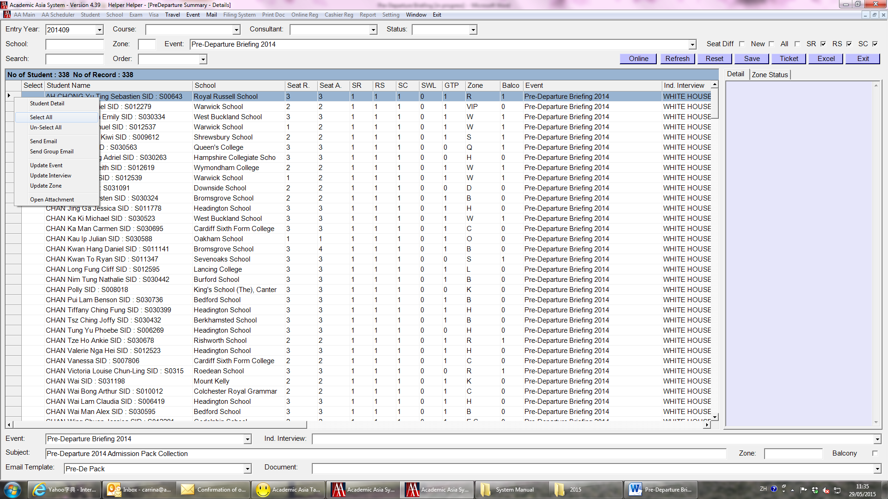

- “1” is shown in the Select column
- Click a box in the column on the left-hand side again right click choose Send Group Email
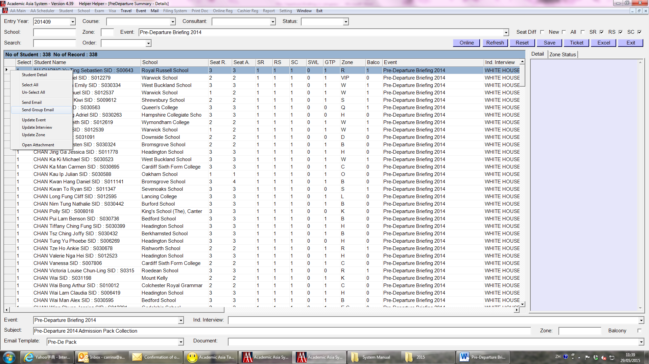

- Repeat the steps of sending group email
6. Prepare the Ticket Pack – Inform families for the collection of ticket pack (con’t)

Print the Students list for families to sign on collection of the Ticket Pack.

- At the top, select Entry Year “201509” and Event “Pre-Departure Briefing 2015”, tick SR + RS + SC
- Click Excel, it takes sometimes to generate the list


- The list is in alphabetical order of surname of student
- Print this and pass it to Front Desk


6. Prepare the Ticket Pack – Inform families for the collection of the ticket pack (con’t)

- Families are requested to present the confirmation email which we have sent them previously for collection of the ticket pack
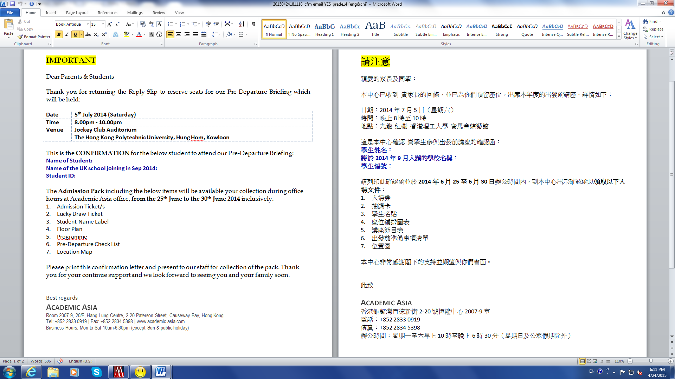

- To ensure they are getting the correct pack, ask them to check the number of tickets and the name of student labels inside the pack, and remind them to bring along the whole pack on event day

- If everything is correct, ask them to sign on the list

- After families collection of the ticket pack

Check the list by the end of the collection period, send reminder email to families if necessary.

- Enter “1” under GTP column to record the signed families click Save
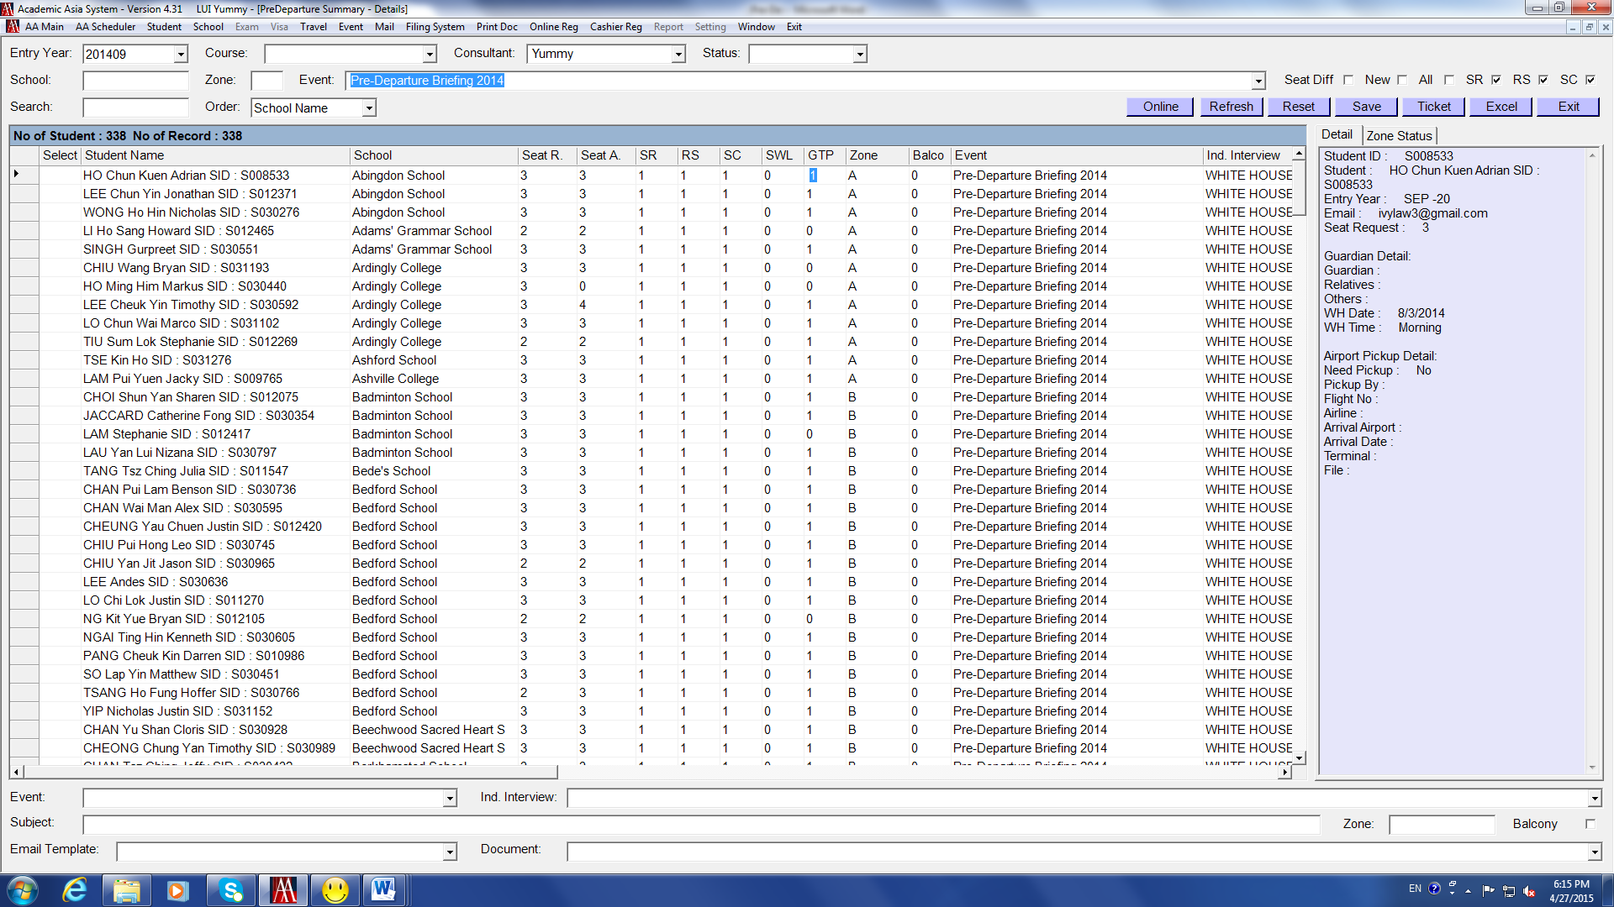

- Repeat the steps of sending group email to those families whose GTP is “0”, to remind them to collect the pack

